Дидактический материал для проведения занятия по английскому языку по теме “Travelling. Survival”

Данный дидактический материал предназначен для развития иноязычной коммуникативной компетенции обучающихся на занятии по английскому языку по теме “Travelling. Survival”. Целью занятия является развитие умений чтения, аудирования и говорения о проблемах, которые могут возникнуть во время путешествий, а также умения вежливо выражать жалобы. Материал может быть использован для работы со взрослыми учениками или детьми старшего школьного возраста, интересующимися заданной тематикой, чей уровень владения английским языком B1 и выше.

]

1 (5 min)
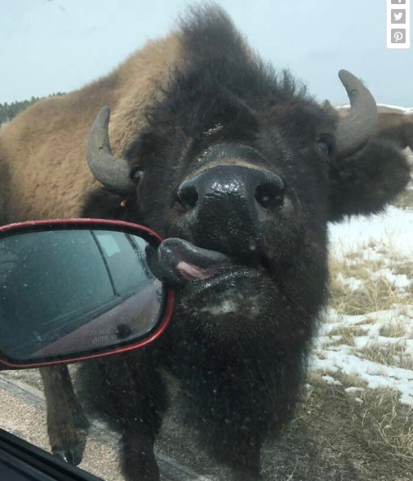

Discuss the questions

1. Do you like travelling? How often do you travel? How many countries have you travelled?
2. Describe two most interesting sights you have seen while travelling in our country or abroad.
a) Where are they situated?
b) How did you get there?
c) What did you do there?
d) Why are they so special to you?
3. While travelling have you ever had any problems with
getting lost
losing something
forgetting something
confusing something
getting ill or other problems?
4. How did you cope with them?

Today we are going to speak about how to react if you have some problems while travelling.

2 (4 min)
Let us meet Gary Arndt who is a famous travel blogger and who has been travelling for more than 12 years.

Read his blog about dealing with the unexpected while traveling and say what problems he had.

My goal today was very simple: I was going to get on the train in the Czech city of Ceské Budejovice (Budwise) and go to Vienna. I would have to make one train switch near the border, but that was it. It should be pretty easy considering there is no border control you have to pass through.
The first problem occurred at the Ceské Budejovice train station. I went to purchase a ticket to Vienna but the woman at the window said I had to go to the international ticket window. Problem was, no one was at the window. In fact, there was a curtain covering the window. I waited and waited until it was almost time for the train to leave.
Not wanting to miss the train, I purchased a ticket to Ceské Velenice which is the border city where I had to switch trains. The schedule showed a 10 minute window where I could run in and buy my ticket to Venice before the next train left.
When I arrived at the Ceské Velenice station, the woman at the counter didn’t speak a word of English and I didn’t speak a word of Czech. I think she knew I wanted a ticket to Vienna, but kept pointing to her computer saying “Kaput. Kaput”.
Either way, buying my ticket didn’t seem in the cards. Eventually someone told me to go to platform 2 to get on the Vienna train. I told them I didn’t have a ticket, but they either didn’t understand nor care.
Once on the train the conductor told me I could just buy a ticket there, but there were two problems: 1) He couldn’t accept credit cards, and 2) I didn’t have any Euros.
So there I was on the train, in a foreign country with no ticket and no means of paying for a ticket.
This is the type of scenario that scares many out of traveling. In the course of 90 minutes I had to deal with language issues, money issues and booking issues.
How did I pay for the train ticket to Vienna? When we got into the station, I went with the conductor to the ticket machine and purchased a ticket for the same route going to opposite way. I handed him the ticket and everyone was happy. (Of course, this could have been avoided if I just had some Euros on me before I left.)
Just the day before when I arrived in Ceské Budejovice, I had no idea where my room was in relation to the train station. I relied on my wits and experience and went to nearest McDonald’s where I knew I’d find an open wifi connection. I pulled up a map on my iPhone and got a walking route. If there wasn’t an open wifi connection, I would have had several other options including getting a taxi at the train station.
When confronted with unexpected obstacles, you will figure out how to get around them. Everyone does.
(https://everything-everywhere.com/dealing-with-the-unexpected-while-traveling/)

Reread the test and say how Gary managed to deal with his problems.

3 (4 min)
If you were Gary, what possible polite questions would you try to ask in every situation? Write them down.
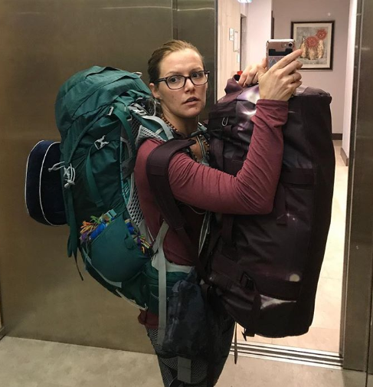
a) He needed to find the international ticket window to buy a ticket to Vienna.
1)
2)

b) He wanted a ticket to Vienna and he addressed to the woman at the train station counter in English.
1)
2)
c) He wanted to get to know on the train if the conductor accepted credit cards to pay for the ticket.
1)
2)
d) He decided to go to the nearest McDonald’s, because he needed to find his hotel room in Ceské Budejovice and had no Internet connection.
1)
2)
_______________________________________________________
4 (4 min)
Meet the other famous travel agent and youtuber Fearless Jacey.
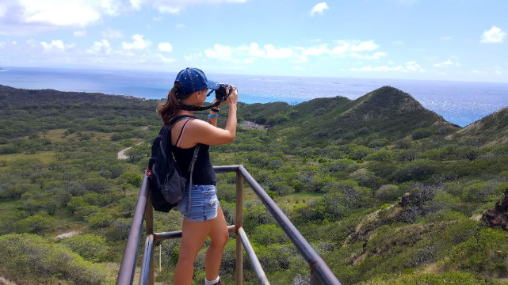
In her video she shares her ideas on a possibility of travel without knowing the local language.
Watch the first part of the video and say what you should pay attention to while you are in a foreign country without knowing the language.

VIDEO 1
(https://www.youtube.com/watch?v=8N1eu9Nl-9M)

(Students’ possible answers are the following:
1.You need to listen to people’s tones.
2.You should listen to the pace of their speech.
3.You should look at people’s body language.)

5 (5 min)
Watch the second part and answer the questions.

VIDEO 2
(https://www.youtube.com/watch?v=8N1eu9Nl-9M)

- Is it really necessary to know the local language in Fearless Jacey’s opinion?
- If somebody is nice to you, what voice and gesture will they have?
- How should a person deal with the menu in an unknown language?
- How is it possible to get from one place to another without knowing the language?
- How can we prepare for the trip better?
_______________________________________________________
6 (5 min)
Even if you carefully plan your vacation, something can still go wrong. When you explore the nature, you can get lost in the jungle, forget your car keys inside the car, or go head to head with a cheetah. Look at the pictures and describe what problems people had.
A. 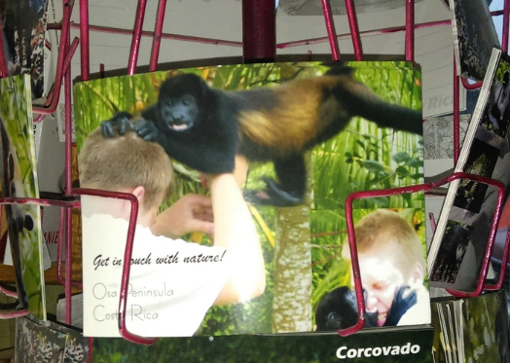
B. 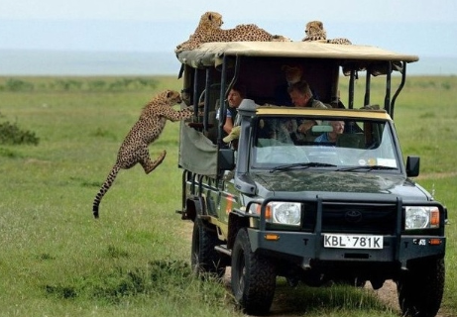
C. 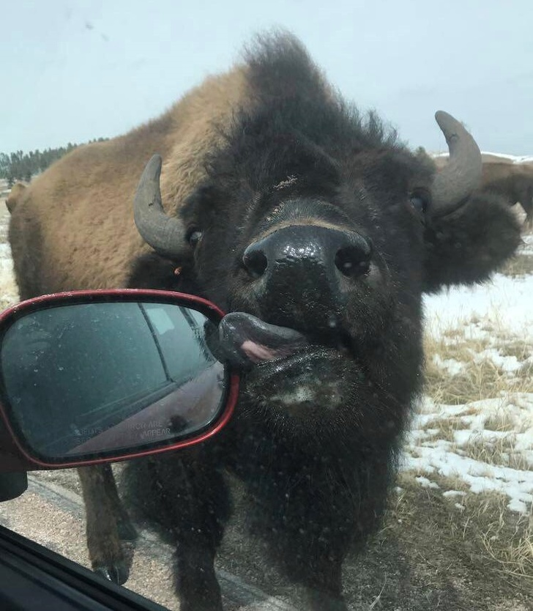
D. 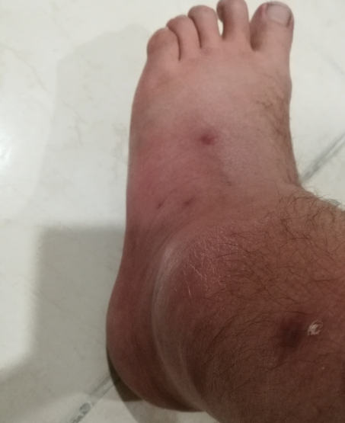

Then make polite complaints to your travel agent about the 4 problems in the pictures. Write them down. Your teacher will check your complaints.
1)
2)
3)
4)
_________________________________________________
7 (3 min)
Complete the tips on how to avoid problems while travelling.
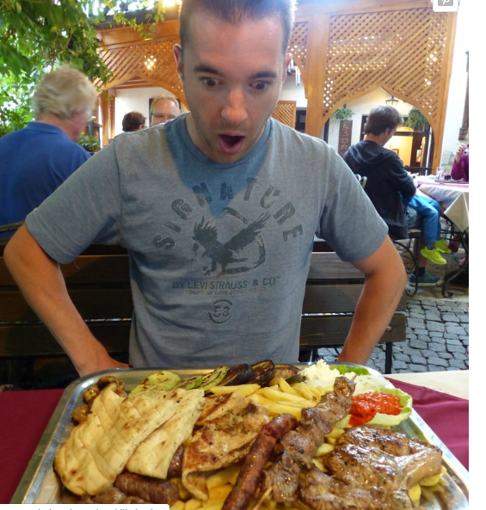
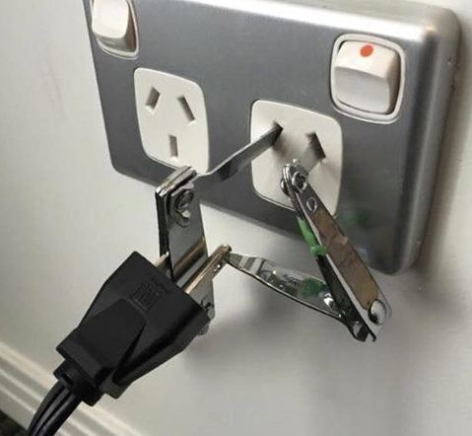

Here are some final tips on avoiding problems while travelling-
Get ready for your trip – 1) …, try to find the objects you need on the map.
If you don’t know the local language, 2) … .
If you need to find a place, use your mobile phone, 3) … .
Do not forget that in the majority of cases local people speak English and 4) … such as –
Excuse me, where can I find the nearest bank?
Could you help me to find this monument?
Could you tell me where I can buy this device?
I have some problem with my wi fi connection, could you help me? etc.

a) you can just make complaints or ask some questions to get the necessary information
b) you need to listen to people’s tones, the pace of their speech, you should look at people’s body language
c) learn some basic phrases in the language of the country you are going to
d) you can download some maps and show the names of the places you need to the taxi driver or other people

Thank you for your work!
Don’t let fear of the unknown stop you from exploring the world.

