“I can fly!”
План индивидуального онлайн-урока на 50 мин для детей 7-9 лет

Vocabulary:to run, to jump, to swim, to walk, to fly, to climb
Grammar: can/can’t

# | stage aims | time | contents
Lesson steps
1 | Lead-in - to engage students in the context of the lesson and raise their interest | 5 | Discuss the questions.  What animals do you like? Why do you like them?  Where do they live?  What colour are they?  Have you got a cat/a dog/a hamster? What is its name? How old is it? What colour is it? Do you love it?
2 | Vocabulary pre-teaching - to pre-teach blocking vocabulary needed for gist reading | 8 | Побудить ученика посмотреть на картинки с животными, выполняющими действия (to run, to jump, to swim, to walk, to fly, to climb), сначала прочитать эти действия для отработки произношения, а потом составить простые фразы по образцу.  - Look at the pictures and say the words after the teacher.  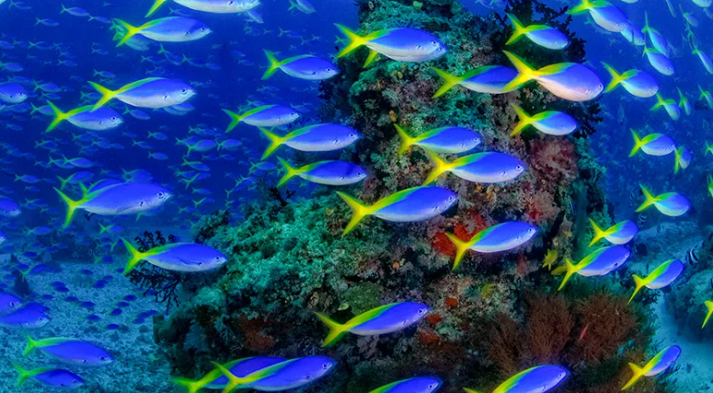swim  …  - Look at the pictures and say which anilmals do that action. For example,  Fish swim.  …
3 | Reading for gist — to set a short task based on general understanding of the text as a whole. | 8 | Read the text and tick the actions cats do:  run,  jump,  swim,  walk,  fly,  climb  What cats can do…  Cats are funny and nice animals. They sleep a lot.  They can do a lot of things. Cats can walk. Cats can also run and jump well. They can climb trees very fast. They hate swimming, but they can do it. They are good swimmers!  But cats can’t fly. They are not birds.
4 | Reading for detailed comprehension — to set a task based on detailed comprehension | 8 | Read the text and mark the sentences as true or false. Correct the false ones.  What cats can do…  Cats are funny and nice animals. They sleep a lot.  They can do a lot of things. Cats can walk. Cats can also run and jump well. They can climb trees very fast. They hate swimming, but they can do it. They are good swimmers!  But cats can’t fly. They are not birds.  - Cats aren’t very nice.  - Cats never sleep.  - Cats run and jump well.  - They are bad at climbing trees.  - Cats love swimming.  - Cats and birds fly.
5 | Focus on the grammar - 1. to present the grammar on the basis of the text.  - to practise it. | 8 | - Look at the phrases and say if cats DO or DON’T DO this:  - Cats sleep a little.  - Cats can climb trees very well.  - Cats cannot swim.  - But cats can’t fly.  What else can cats do?  - Discuss the questions.  - What can monkeys do?  - What can parrots do?  - What can’t crocodiles do?  - What can’t dolphins do?  - What can dogs do?
6 | Follow up activity — to do a speaking/writing activity based on the text. | 8 | Make up a story about what your pet or your friend’s pet CAN or CAN’T do.
7 | Cool Down | 5 | Discussion of the question “What have you learned today?”  Feedback on students’ work, praising for good work  Homework preview

