Министерство образования и науки Хабаровского края
КГБ ПОУ ХПЭТ «Хабаровский промышленно-экономический техникум»

РЕФЕРАТ
ДИСЦИПЛИНА: Иностранный язык
ТЕМА: «Россия. Символы и традиции страны»

Выполнил:
Звенова Д.Д. студентка гр. ОБАС-11
Проверил: Перевозникова Л.В
преподаватель иностранного языка

Хабаровск 2021
Содержание

Пояснительная записка 3
HISTORY OF THE NATIONAL FLAG OF RUSSIA 4
Coat of arms of Russia 6
Brief description and meaning of the symbols of the Coat of Arms of Russia 6
How were the symbols on the coat of arms of the Russian Federation formed and what do they mean? 7
What do the elements of the images on the coat of arms of Russia mean?: three crowns 7
The meaning of the Coat of Arms of the Russian Federation 8
History of the national anthem of Russia 8
Past hymns 8
The national anthem of the Russian Federation now 9
Заключение 12
Список литературы 13

Пояснительная записка

Одним из приоритетных направлений в настоящее время является воспитание у учащихся любви к Родине, ценностного отношения к родному краю.
Общественное развитие России происходит в условиях сложной внутренней и международной обстановке. Утрачены многие духовные ценности.
Сейчас как никогда необходимо возрождение духовности, воспитание любви к Родине.
Необходимость обращения к истокам народного искусства, традициям, обычаям народа не случайно. Не секрет, что помимо экономических трудностей, наша страна сейчас испытывает проблемы в воспитании подрастающего поколения. Нарушились традиции, порвались нити, которые связывали старшее и младшее поколения. Поэтому, очень важно возродить преемственность поколений, дать детям нравственные устои, патриотические настроения, которые живы в людях старшего поколения, обогатить детей знаниями национальной культуры.

HISTORY OF THE NATIONAL FLAG OF RUSSIA

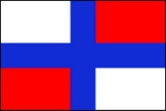
1668
Until the XVII century, there was no single state flag in Russia. The first mention of it is associated with the name of Tsar Alexei Mikhailovich Romanov. In 1668, in accordance with European tradition, he ordered the flag to be raised over the first Russian warship, named "Eagle". It is known that scarlet, white and blue fabrics were purchased for the production of the first flag, although there is no exact information about how it looked. In this regard, there are several versions, according to one of them; a double-headed eagle was also depicted on the flag. It is believed that the type of the first naval flag went back to some of the Streltsy banners of the mid-XVII century, and even earlier periods.

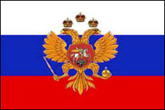
1693
This year, while sailing on the White Sea, Peter I first used the "flag of the Tsar of Moscow" on his yacht. The flag consisted of three horizontal stripes (white, blue and red), in the center of the flag was a golden double-headed eagle. Thus, the fleet has its own single flag, which can de facto be considered the national flag of Russia.

1705
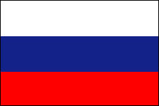
On January 20, Peter I issued a decree on the placement of a white-blue-red flag on merchant ships. This flag was also used as the military field flag of the Russian army, and white-blue-red scarves were part of the officer's uniform from 1700 to 1732.

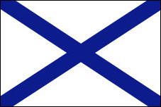
1712
The navy approved the white St. Andrew's flag with an azure cross, created in honor of the Order of St. Andrew the First-Called. The layout of the flag was created personally by Peter I.

1858
Alexander II approved a new design of the flag for special occasions (black-yellow-white). The initiator of the changes was Baron Kene, who drew the attention of the emperor to the fact that the colors of the flag do not correspond to the colors of the coat of arms, while this circumstance contradicted the rules of German heraldry.
1865
There was a decree in which black, orange (gold) and white were called the state colors of the Russian Empire. Its color was the symbol of the earth, the gold and silver. Note that the black-yellow-white flag has never been popular in society – too strong were the associations with Austria and the house of Habsburg.

1883
During the celebration of the coronation of Alexander III, the emperor drew attention to the contrast of the festive procession, decorated with black-yellow-white flowers, and the city, which was dominated by white-blue-red colors. On April 28, 1883, the emperor ordered that the white-blue-red flag of the merchant navy be used exclusively on solemn occasions.
1896
On the eve of the coronation of Nicholas II, the Peter the Great tricolor was officially awarded the status of the state flag. At the same time, the red color symbolized "power", the azure color – the patronage of the Mother of God, and the white color – freedom and independence.

1918
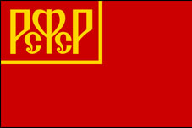
In April of this year, at the suggestion of Sverdlov, the red flag with the golden inscription of the RSFSR in the upper left corner became the state flag. The idea of the flag, apparently, was borrowed from the European revolutionaries and socialists.

1954
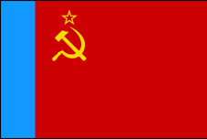
Up to this time, the state flag of the RSFSR was often replaced by a red cloth without inscriptions and drawings. On May 2, 1954, the final version of the flag was approved by the decree of the Presidium of the RSFSR. Now the flag consisted of a red cloth with a light blue stripe at the flagstaff across the entire width of the flag. On the red cloth, in the upper left corner, there was a golden hammer and sickle, and a red five-pointed star, bordered with gold, above them.

1991
On August 22, 1991, a new history of the flag of Russia began. The national flag was recognized as a rectangular panel with different horizontal stripes of white, blue and red colors and an aspect ratio of 1:2. Since 1994, August 22 has been declared the Day of the State Flag of the Russian Federation.
1993
On December 11 of this year, Russian President Boris Yeltsin issued Decree No. 2126 "On the State Flag of the Russian Federation", which approved the colors and proportions of the flag in the form in which we have them now.

Coat of arms of Russia
What is the Coat of Arms of Russia
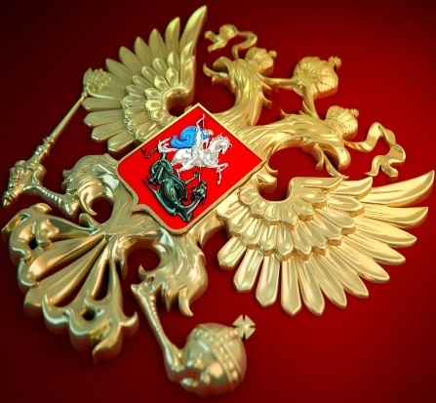
This is a special emblem made in accordance with the heraldic canons.
It is an interconnected system of images and colors, which carries the idea of the integrity of the state and is inextricably linked with its history, traditions and mentality.
The appearance of this official sign is enshrined in the Constitution.

Brief description and meaning of the symbols of the Coat of Arms of Russia
This badge of state distinction is a red heraldic shield, in the middle of which is a golden double-headed eagle. In the left clawed paw, the bird holds an orb, and in the right-a scepter.
On each of the heads is a crown, and at the top is another, larger one. All three royal headdresses are connected by a gold ribbon.
In the center of the shield, on the chest of the eagle, there is another red cloth. It has a plot familiar to every Russian person: St. George the Victorious kills a snake.
There are lots of icons and pictures to illustrate the story. This is the most recognizable image of the saint. On the emblem, he is represented as a silver rider on a silver horse, dressed in a blue cloak. A monster under the hooves of a black horse.

How were the symbols on the coat of arms of the Russian Federation formed and what do they mean?
Today, heraldry is an auxiliary branch of historical science. The emblems of the countries, along with the chronicles and chronicles, represent the most important historical evidence.
In Western Europe during the time of chivalry, every noble family had a symbol inherited from generation to generation. He was present on the banners and was a badge of distinction, by which the representative of the family was recognized both on the battlefield and at the feast. In our country, this tradition has not been developed. In battle, the Russian wars carried with them embroidered images of the Great Martyrs, Christ or the Virgin. The Russian heraldic sign originates from the princely seals.

What do the elements of the images on the coat of arms of Russia mean?: three crowns
One of them also appears under Ivan IV. It was located on top and was decorated with an eight-pointed cross, as a symbol of faith. The cross has appeared before, between the bird's heads.
In the time of Fyodor Ioanovich, the son of Ivan the Terrible, who was a very religious ruler, it was a symbol of the passion of Christ. Traditionally, the image of the cross on the coat of arms of Russia symbolizes the country's acquisition of ecclesiastical independence, which coincided
with the reign of this tsar and the establishment of the patriarchate in Russia in 1589. At different times, the number of crowns changed.
Under Tsar Alexei Mikhailovich, there were three of them, the ruler explained this by the fact that then the state absorbed three kingdoms: Siberian, Kazan and Astrakhan. The appearance of the three crowns was also associated with the Orthodox tradition, and was interpreted as a sign of the holy Trinity.
At the moment, it is known that this symbolism on the coat of arms of the Russian Federation means the unity of the three levels of government (state, municipal and regional), or its three branches (legislative, executive and judicial).
Another version suggests that the three crowns mean the brotherhood of Ukraine, Belarus and Russia. The crowns were fastened with a ribbon already in 2000.
What does the Coat of arms of the Russian Federation mean?: the scepter and Orb
They were added at the same time as the crown. In earlier versions, the bird could hold a torch, a laurel wreath, and even a lightning bolt.
Currently, the eagle that holds the sword and the wreath is on the banner. The attributes that appeared on the image represented autocracy, absolute monarchy, but also indicated the independence of the state. After the revolution of 1917, these elements, like the crowns, were removed. The provisional Government considered them a relic of the past.
Seventeen years ago, they were returned and now adorn the modern state insignia. Scientists agree that in modern conditions, this symbolism of the coat of arms of Russia means state power and the unity of the state.

The meaning of the Coat of Arms of the Russian Federation
The drawing of the modern state symbol was made by the St. Petersburg artist Yevgeny Ukhnalev. He left out the traditional elements, but created a new image. The fact that the final version included signs from different eras underlines the long history of the country. The type of this personification of state power is strictly regulated and described in the relevant laws.
The shield is a symbol of the protection of the earth. At the moment, the meaning of the coat of arms of the Russian Federation is interpreted as a fusion of conservatism and progress. The three rows of feathers on the bird's wings refer to the unity of Kindness, Beauty and Truth. The scepter became a sign of state sovereignty. Interestingly, it is decorated with the same double-headed eagle, clutching the same scepter and so on indefinitely.
Briefly, we can say that the coat of arms of Russia symbolizes eternity, means the unity of all the peoples of the Russian Federation. The power is an emblem of power and integrity.

History of the national anthem of Russia
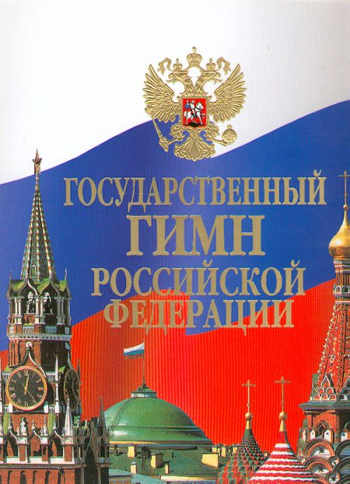
The first unofficial Russian anthem was "Thunder of Victory, Be Heard!", created by Gavrila Romanovich Derzhavin. But it appeared at the end of the XVIII century and glorified mainly not the country, but Catherine the Great. It is not surprising that it was changed quite quickly, and the official anthem of Russia that exists today is completely different from it.

Past hymns
- At the end of 1816, Emperor Alexander I signed a decree that the melody and verses "The Prayer of the Russians" were used during the meeting of official foreign guests. This hymn lasted until 1833. By the way, the author of his words was the great Russian poet Vasily Andreevich Zhukovsky;
- The next was " Since our Lord is glorious in Zion." The words were written by Mikhail Matveevich Kheraskov. From 1856 to October 1917, the music of this hymn was performed when the Chimes on the Spasskaya Tower of the Kremlin rang. This hymn was much less secular than the last one. And it was because of this that it was immediately banned by the Bolsheviks who came to power;
- In parallel with the previous one, there was a hymn " God save the King!". It was approved by Nicholas I. The words were again created by Vasily Andreevich Zhukovsky. In many ways, this anthem echoed the European ones, which also caused great dislike on the part of the Soviets. There were even proposals to ban it completely;
- "International" is the official national anthem of the RSFSR and the USSR in the period from 1918 to 1944. He was also completely imbued with the idea of the world domination of communism, the struggle against tsarism and the bourgeoisie. By the way, the music and words without translation were written by famous French revolutionaries of that era;
- In 1944, a new anthem appeared, which already had a victory motif, in particular in the Battle of Stalingrad. It was after her that the song appeared. The music was created by the composer Alexander Vasilyevich Alexandrov, and the words were created by the famous poet Sergei Vladimirovich Mikhalkov;
- After the collapse of the Soviet Union, namely in the period from 1990 to 2000, there was no official anthem, but there was a "Patriotic Song" by Mikhail Ivanovich Glinka. Already during the presidency of Boris Yeltsin, the "Patriotic Song" was recognized as the national anthem of the RSFSR.

The national anthem of the Russian Federation now
The creation of a unique national anthem for Russia was started on March 10, 1999. It was then that the consideration of the law "On the National Anthem of the Russian Federation" began in the State Duma. But it was fully adopted and signed only in 2001, as the process of selecting the best option turned out to be quite long.
The uniqueness of the current anthem is that it combines Soviet music, created by Alexandrov, and new words. The words, by the way, were developed by several authors. As a result, Vladimir Putin personally listened to proposals from twelve representatives of the working group. As a result, we decided on the text proposed by Sergey Mikhalkov. It is rhythmically very similar to the one that was in the RSFSR, but it differs in meaning. He points to the unity of the sovereign peoples of Russia and its desire for a bright, but no longer communist future.
As a result, in the spring of 2001, the State Duma introduced five versions of the verses that had to be put to music for the anthem. The President openly supported Mikhalkov's text. His opinion coincided with the opinion of the deputies, so since March 7, 2001 in the Russian Federation there is an official national anthem, included in the Constitution and protected by law. For example, people who intentionally change and defame the text of the anthem can be brought to justice. And every modern schoolchild is obliged to know and be able to correctly perform the
Russian anthem, when it needs.
Public holidays.

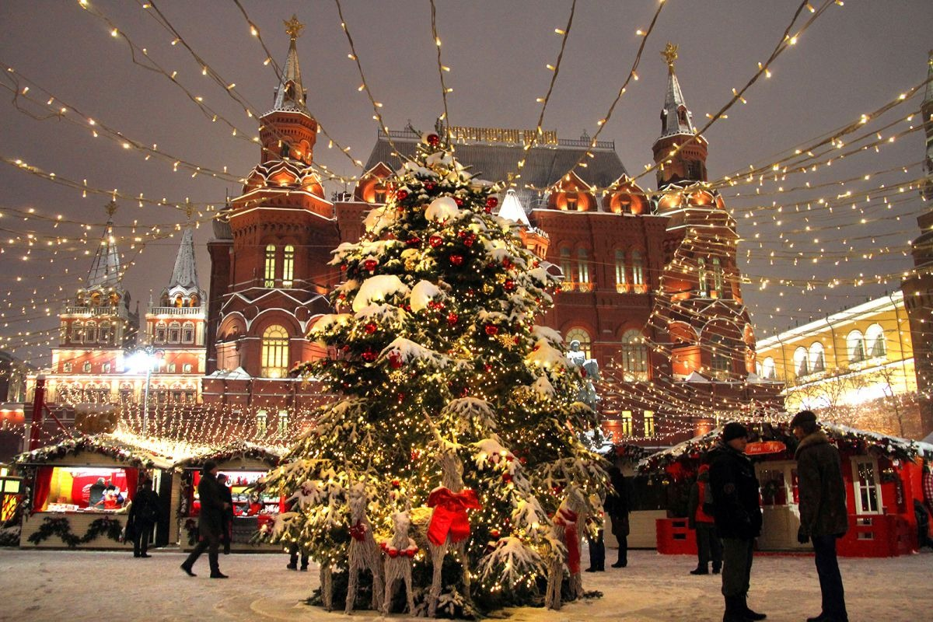
- When to celebrate: December 31—January 1
In Russia, the largest holiday is the New Year. It is celebrated on a grand scale, while managing to combine a family feast with fun outside the house. As a rule, December 31 is spent on preparing a festive feast or party: close relatives and friends gather together and cut salads, decorate houses and watch Soviet classics, which are played from morning to evening on federal channels.
Traditional New Year's dishes and products — jelly, salad "Olivier" and herring "under a fur coat", smoked sausage, tangerines, chocolate, champagne. It is not necessary that everything will be on the table at once, but some of the above is mandatory. At the very least, tangerines and champagne.
Interestingly, Russians rarely prepare for the holiday in advance, as they do in Western countries. Even a Christmas tree or pine tree is often bought a couple of days before the celebration, and decorate the house and wrap gifts at the last moment. But this does not make the New Year any less joyful and expected.
As the chimes strike, people drink champagne, and then many go outside to watch the fireworks. On TV at this time, they broadcast endless concerts of Russian and foreign pop stars.
From January 1 to January 8, most employees leave for the New Year holidays.

Defender of the Fatherland Day
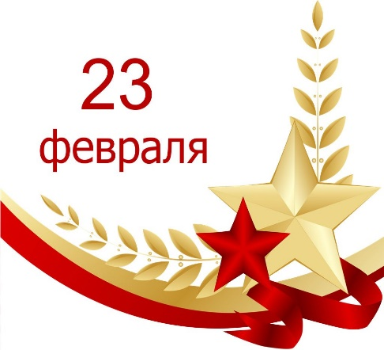
- When to celebrate: February 23.
This holiday originated almost 100 years ago, in 1922. Then it was listed as the Day of the Red Army and Navy, and later-the Day of the Soviet Army and Navy.

The holiday became a non-working day in 2002 and has especially taken root in the corporate culture: the female part of the team annually prepares congratulations to all men, regardless of whether they served in the army or not. If February 23 falls on a Friday or Monday, then Russians use a long weekend to go for a rest: go skiing or meditate by the pre-spring sea.

International Women's Day

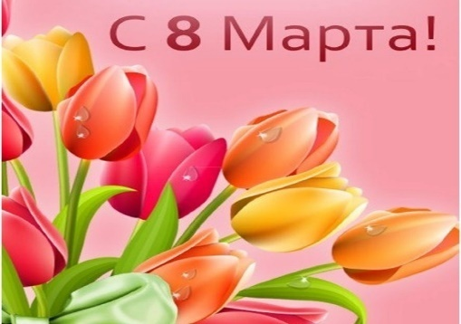
- When to celebrate: March 8
This holiday is celebrated in different countries around the world. It appeared as a day of solidarity for women in the struggle for equal rights and emancipation. But in modern Russia, many perceive it as a holiday of spring and beauty, which goes against the true meaning of March 8. But starting from March 7, you can see how men travel around the city with bouquets and everywhere congratulate women.From the point of view of the weekend, March 8 is used in the same way as Defender of the Fatherland Day: go away for a long weekend or join the weekend with spring break for a full-fledged trip.

Victory Day
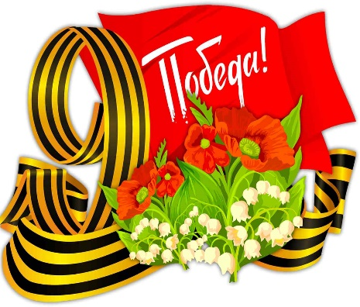
- When to celebrate: May 9.
Victory Day is one of the most touching and solemn holidays of the year. The holiday is dedicated to the victory of the Soviet people over Nazi Germany in the Great Patriotic War. In 2020, the Russians will celebrate 75 years of victory.
In many cities, May 9 begins with a military parade, and ends with a festive salute. During the day, concerts and outdoor events are held, and traffic on the main streets in major cities is blocked to admire the parade of military equipment.
In the 2010s, a national procession with portraits of veterans called "The Immortal Regiment"became a mandatory attribute of the celebration.

Easter
- When it is celebrated in April, and rarely in March.
Despite the fact that Easter is also a religious holiday, it is celebrated by most Russians. This is probably due to the colorful Easter traditions. The main dish of the festive feast is cakes made of special dough, symbolizing the body of Christ. They are baked for sale in all pastry shops, bakeries and even supermarkets with their own production. But especially valuable are homemade cakes baked by housewives on the eve of Easter. Festive pastries are decorated with protein filling and colorful confectionery sprinkles.In addition to cakes, the Easter table is served with colored eggs and a plentiful treat, including meat and fish dishes, since the holiday is preceded by 40 days of Great Lent. A special trick of Russian housewives is to paint eggs in boiled onion husks, which turns out to be a thick reddish-brown shade.
From oral traditions, it is customary to exchange greetings at Easter: "Christ is risen!", to which the answer is"Truly risen!".

Pancake day
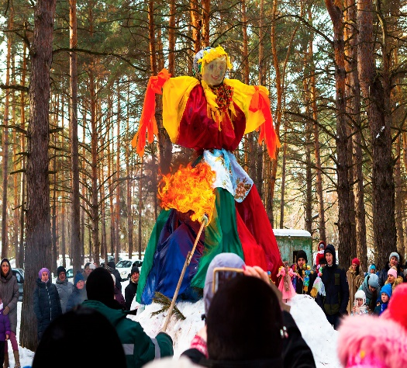
- When they celebrate: in February, less often in March.
Maslenitsa is a pagan holiday that has preserved elements of Slavic mythology. It lasts a week before the beginning of Lent and marks the transition from winter to spring. The exact timing of Maslenitsa depends on the Easter date. Shrovetide week is divided into two parts: from Monday to Wednesday — a Narrow Shrovetide, from Thursday to Sunday — a Wide One. On the last day of Maslenitsa, an effigy is burned, symbolizing winter.The main Shrovetide dish is pancakes with all kinds of fillings: from sour cream to red caviar. It is customary to bake them at home with family and friends, but you can get together on Shrovetide and in some cafe or coffee shop: catering establishments develop a special menu for the holiday week and actively feed everyone pancakes.

Заключение
Каждое современное государство имеет символы своего суверенитета –главные отличительные знаки. Символы государства – это свидетельства его суверенитета, по которому оно узнается во всем мире. Я считаю, что эти символы несут на себе огромную идеологическую, правовую, социально- политическую нагрузку. Любовь к своей стране выражается и через эмоциональное отношение к ее государственным символам. Когда я слышу звуки родного гимна, мое сердце бьется взволнованно. При подъеме флага в знак победы на международных спортивных соревнованиях у победителей наворачиваются слезы на глаза, а болельщики решительно раскрашивают лица в цвета государственного флага.

На мой взгляд, каждый гражданин, особенно подросток должен знать историческую и современную символику государства. Это непременное условие его социального и личностного становления, которое невозможно без гражданственной составляющей. Я считаю, что знакомство с символами государства подводит школьников к тому, что к существовавшим и существующим символам государства надо относиться с уважением, чтить их памятники прошлого и достояние современности. Посягательство на государственные символы во всех странах мира воспринимаются как знак неуважения и враждебности к стране, ее народу; влекут за собой ответственность в соответствии с законодательством страны.

Формирование уважения к символам государства является важной составной частью воспитания гражданина России.

Список литературы
- https://blog.ostrovok.ru/prazdniki-v-rossii/
- https://kakoy-smysl.ru/history-of-creation/istoriya-sozdaniya-gosudarstvennogo-gimna-rossii/
- https://дом-родословия.рф/blog/chto-oznachaet-gerb-rossii
- https://ru.wikipedia.org/wiki/Гимн_России

