**An Eco-School**

**Класс:** 9

**Цель:** обучение монологической речи по теме ‘An Eco-School’.

1. Read the information and discuss the questions in pairs.

* What are your top three environmental worries?
* What do you recycle, turn off and do more or less of to protect the environment?

**Did you know that 2/3 of British teenagers admit they can do more to protect the environment?**



What are British teenagers’ top three environmental worries?

* Poor air quality
* Global warming
* Not enough recycling

What do British teenagers say they can do?

* Recycle more
* Turn off unnecessary lights
* Spend less time in shower

1. Complete the sentences with the correct words.

bins, bulbs change energy, issues, panels, warming

1. Solar ________ make buildings look ugly.
2. There aren’t any recycling ________ in my area.
3. Climate ________ doesn’t affect my country.
4. More renewable ________ is the only way to stop global ________.
5. Everybody should use low-energy light ________ to save electricity.
6. Our government is not interested in environmental ________.
7. Look at the picture of an eco-school. Which features would you expect it to have?

* a bicycle rack
* a fast-food canteen
* a large car park
* low-energy light bulbs
* an organic vegetable garden
* more recycling bins
* science lessons on global warming
* solar panels
* technology lessons on renewable energy

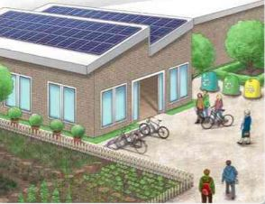

1. Listen to an interview about a project for an eco-school. Which features from the precious exercise are mentioned?
2. Listen again and choose the correct answer.
3. ‘Friends of the Planet is an after-school club with members from
4. one school
5. seven schools
6. six schools
7. What is the project?
8. to make environmentally-friendly changes to schools
9. to create a new type of solar panel for schools
10. to help design a new environmentally-friendly school
11. School dinners will include vegetable from
12. a local farm
13. the local supermarket
14. the school garden
15. Science and Technology lessons will
16. be the same as in other secondary schools
17. not focus on climate change
18. concentrate a lot on environmental issues
19. The interview comments that
20. Michael is probably not a typical teenager
21. Michael is like every other student of his age
22. Michael likes games and gadgets
23. In pairs, look at the logos for a new eco-school. Which one would you choose? Why?

*I think logo 1 is the best logo because it is clever and effective.*

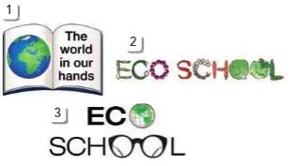

1. Imagine that a school wants its students to understand more about environmental problems. Look at the diagram. In groups, follow these steps.

* *Talk to each other about whether you think these are good ways to help students understand about environmental problems.*
* *Decide which of the things it would be best for the school to do.*

organize a talk by a weather expert

visit a recycling plant

Which of these things would it be best for the school to do?

take students to the streets clear-up

watch documentaries in class

put up posters in the classroom