**Васильева Е.С.**

**ГБОУ Академическая Гимназия № 56 им М.Б. Пильдес**

**(г. Санкт-Петербург)**

***Урок-квест «Santa Claus’s reindeer”***

***Цель урока:*** познакомить учащихся 3-4 классов с некоторыми обычаями и традициями празднования Рождества в англоязычных странах, повышение познавательно интереса учащихся.

***Задача квеста:*** узнать имена всех оленят, которых Санта Клаус запрягает в свои рождественские сани.

***Ход квеста:*** учащиеся выполняют задания, ответами на которые являются имена оленят. Получить следующую загадку можно только узнав, как зовут предыдущего олененка.

***Задание 1:*** Посмотреть отрывок из мультфильма “Rudolph the red nosed reindeer”, 1948г . и вставить пропущенные слова в предложения. Расположить предложения в правильном порядке и узнать имя первого оленёнка.

*Watch the cartoon, complete the missing words and then put sentences in the correct order and find out the name of the reindeer from the first letters of the missing words:*

*team Eve Christmas mommy on*

1. Rudolph wrote a letter to his __________ and daddy and went to help Santa.
2. Santa woke up and got ready to his ________________ flight.
3. Rudolph the red-nosed reindeer became the first in the reindeer _________.
4. Rudolph’s nose lit the way and Santa delivered all the presents on Christmas ____________.
5. Santa’s sleigh fell _______ a tree because of the fog.

***Ответ:*** *Comet*

***Задание 2:*** Расставить картинки из мультфильма в правильном порядке. Из букв под картинками получится имя следующего оленёнка.

*Put the pictures in the correct order. Make up the name from the letters under the pictures.*

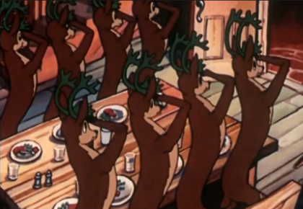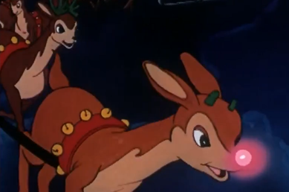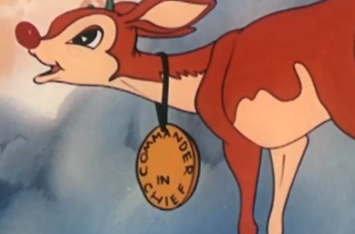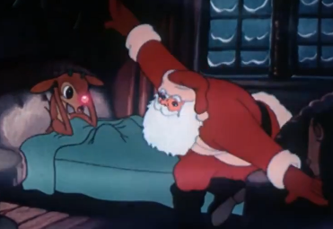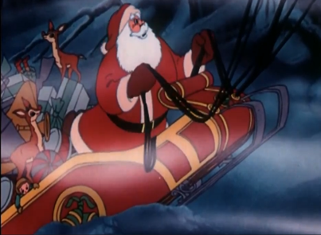 **H R E**

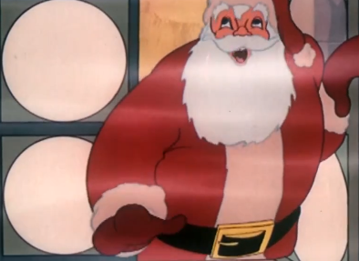**S** **D**  **A**

***Ответ:*** *Dasher*

***Задание 3:*** Разгадай кроссворд.

*Do the crossword:*

*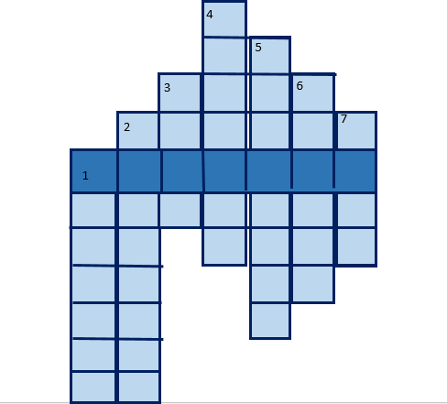1.*

*2.*

*3.* 

*4.*

*5.* 

*6.*

7.

***Ответ:*** Prancer

***Задание 4:*** Соединить традиционные рождественские блюда Великобритании с картинками.

*Match the words to the pictures:*

|  |  |  |  |
| --- | --- | --- | --- |
| *1.* | *Roast Turkey* | *R* | https://img.freepik.com/premium-vector/print_325203-916.jpg?size=626&ext=jpg |
| *2.* | *Christmas Pudding* | *N* | https://vkusno-prigotovim.ru/wp-content/uploads/c/e/9/ce90f7fc0d06202904dbbf0f9090b527.jpeg |
| *3.* | *Cranberry Sauce* | *E* | https://cooklikeczechs.com/wp-content/uploads/2021/08/czech-braised-red-cabbage-recipe.jpg |
| *4.* | *Beef Wellington* | *N* | https://i.pinimg.com/originals/ad/16/5b/ad165b0bdf5776761e6b28d357ed00dd.jpg |
| *5.* | *Braised Red Cabbage* | *O* | https://media.istockphoto.com/illustrations/delicious-xmas-fruitcake-pudding-dessert-illustration-id163855643?k=6&m=163855643&s=612x612&w=0&h=gCleemZbtn_z5xORKJrtaFoLYk7fM4v-xaWO9l26xWo= |
| *6.* | *Mince Pies* | *D* | https://helpiks.su/imgart/baza1/9709627662195.files/image003.png |

|  |  |  |  |  |  |
| --- | --- | --- | --- | --- | --- |
| ***1*** | ***2*** | ***3*** | ***4*** | ***5*** | ***6*** |
|  |  |  |  |  |  |

***Ответ:*** DONNER

**Задание 5:** прочитать стихотворение и разгадать шифр

*Read the poem and unravel the cipher:*

1. *The 1st line, the 13th letter*
2. *The 3rd line, the 14th letter*
3. *The 5th line, the 17th letter*
4. *The 6th line, the 15th letter*
5. *The 9th line, the 22nd letter*
6. *The 18th line, the 1st letter*

**Rudolph the Red-Nosed Reindeer**

*Rudolph, the red-nosed reindeer  
Had a very shiny nose.  
And if you ever saw him,  
You would even say it glows.*

*All of the other reindeer  
Used to laugh and call him names.  
They never let poor Rudolph  
Join in any reindeer games.*

*Then one foggy Christmas Eve  
Santa came to say:  
“Rudolph with your nose so bright,  
Won’t you guide my sleigh tonight?”*

*Then all the reindeer loved him  
As they shouted out with glee,  
“Rudolph the red-nosed reindeer,  
You’ll go down in history!”*

|  |  |  |  |  |  |
| --- | --- | --- | --- | --- | --- |
| ***1*** | ***2*** | ***3*** | ***4*** | ***5*** | ***6*** |
|  |  |  |  |  |  |

***Ответ:*** DANCER

***Задание 6:*** Послушать песню “Jingle Bells” и расставить строчки в правильном порядке

*Listen to a song “Jingle Bells and put the lines in the correct order”*

|  |  |
| --- | --- |
| *L* | Over the fields we go,  Laughing all the way; |
| *Z* | Jingle bells, jingle bells,  Jingle all the way! |
| *I* | Bells on bob-tail ring,  Making spirits bright, |
| *E* | O, what fun it is to ride  In a one-horse open sleigh |
| *T* | What fun it is to ride and sing  A sleighing song tonight, O |
| *B* | Dashing through the snow  In a one-horse open sleigh, |
| *N* | Jingle bells, jingle bells,  Jingle all the way!  O what fun it is to ride  In a one-horse open sleigh |

|  |  |  |  |  |  |  |
| --- | --- | --- | --- | --- | --- | --- |
| ***1*** | ***2*** | ***3*** | ***4*** | ***5*** | ***6*** | ***7*** |
|  |  |  |  |  |  |  |

***Ответ:*** BLITZEN

***Задание 7:*** Разгадать загадки

*Guess the riddles:*

1. *It is red and white. It is sweet. Kids like it. _ _ _ _ _ _ _ _*
2. *He’s kind and fat/ He gives presents to everybody. _ _ _ _ _ _ _ _ _ _*
3. *Santa puts them under the Christmas tree. _ _ _ _ _ _ _ _*
4. *It is Santa’s transport. _ _ _ _ _ _*
5. *It can light a room. It can burn. _ _ _ _ _ _*

|  |  |  |  |  |
| --- | --- | --- | --- | --- |
| ***1*** | ***2*** | ***3*** | ***4*** | ***5*** |
|  |  |  |  |  |

***Ответ:*** CUPID

***Задание 8:*** сопоставить 5 оленят с их отличительными чертами

*Match 5 reindeer with their personalities:*

|  |  |  |  |
| --- | --- | --- | --- |
|  | Dasher | X | He’s very funny. He likes playing hide-and-seek. |
|  | Cupid | E | He can dance all kinds of dance |
|  | Prancer | V | He’s very fast |
|  | Dancer | N | He’s the youngest. He wants to be a teacher. |
|  | Comet | I | He’s lovely. He falls in love |

|  |  |  |  |  |
| --- | --- | --- | --- | --- |
| ***1*** | ***2*** | ***3*** | ***4*** | ***5*** |
|  |  |  |  |  |

***Ответ:*** VIXEN

***Подведение итогов:*** подсчитываем сколько оленят каждая группа/ класс смогла прикрепить в упряжку Санта Клауса за 40 минут и распределяем места.