Устный журнал как форма организации работы по английскому языку
Афанасенкова Людмила Михайловна
В последние годы иностранный язык становится все более востребованным. Появилось множество современных учебников и пособий не только отечественных авторов, но и зарубежных издательств. Мы работаем по учебникам Кузовлева В.П. В учебниках содержится очень много информации по всем сферам жизни и деятельности человека.
Каждый учитель стремится донести до учащихся эту информацию и дать как можно больше знаний. Но не всегда можно уместить эту информацию в рамки одного урока. Например, при изучении темы “How do you treat the Earth?” в 7 классе, “Would you like to go to Britain?”, “Traditions and Manners” в 8 классе, “Healthy living guide” в 9 классе просто невозможно использовать весь предлагаемый авторами материал во время урока.
Приходится искать какие-то новые пути. В 70-е и 80-е годы была популярна такая форма работы как “Устный журнал”. Сейчас ее вытеснили более современные формы работы, метод проектов, например. Мне кажется, что устный журнал дает учителю не меньше возможностей для работы, чем метод проектов.
Хочу представить вниманию коллег опыт работы над устным журналом “Environment and people”.
На первом уроке раздела мы рассмотрели все подтемы цикла и определили количество и название “страниц” нашего журнала. Учащихся класса поделили на группы в соответствии с количеством страниц. Каждая группа должна была найти дополнительный материал по своей теме, обработать его, найти необходимый иллюстративный материал и готовить свою страницу. За две недели работы над материалом цикла учащиеся могут спокойно подготовить все необходимое. Затем каждая группа оформила свою страницу на листе ватмана. На презентацию устного журнала были приглашены учащиеся параллельного класса и второй группы класса, который этот журнал готовил.
Устный журнал “Environment and people”
Цели и задачи:
- Социокультурный аспект – знакомство с реалиями и понятиями the RSPB, the RSPCA, WWF.
- Развивающий аспект – развитие способности к обобщению, логичности и доказательности.
- Воспитательный аспект – формирование умения работать в коллективе, формирование уважительного отношения к мнению других, формирование ответственного отношения к проблемам окружающей среды.
- Учебный аспект – совершенствование речевых навыков по теме.
- Сопутствующая задача – скрытый контроль ЗУН учащихся по всем видам речевой деятельности.
Оборудование:
- Постеры с текстами, подготовленные учащимися.
- Компьютер.
- Медиапроектор.
- Презентация “How do you treat the Earth”.
- Карточки с заданиями.
- Магнитофон.
- Телевизор и видеомагнитофон.
- Аудиозапись текста для аудирования.
- Видеозапись сюжетов о защите животных в Великобритании и США.
- Аудиозапись песен “We kill the world” (Boney M) и “Прости, Земля” (Земляне)
Технологии: ИКТ, игровая технология, здоровьесберегающая технология, разноуровнего обучения.
Ход занятия
I. Вступительное слово учителя.
Звучит песня “Прости, Земля” в исполнении группы Земляне.
Dear boys and girls! You are listening to a song. This song is called “Прости, Земля”. What is it about? It is about the beauty of our planet and about killing it by people. You know that the ecological problem is one of the global problems of mankind. At our lessons we spoke much about this problem, but we didn’t have enough time to discuss it. That’s why we have an unusual lesson today. It is called “Environment and people”. The pupils of the 7th form have prepared it. Look here, please! You can see some posters here. But they are not simple posters, they make up a magazine. Do you like magazines? Let’s read it! The first page is called “Pollution”.
Группа учащихся представляет свой постер, в котором рассказывается о загрязнении окружающей среды. Во время рассказа дети показывают иллюстративный материал на постере.
P1: Pollution is a thing, which appears because of people’s actions. People work at the factories, drive cars. These factories and cars put a lot of harmful gases into the air. The air is so polluted in some places that it’s not always safe to breathe! Many cities around the world have air filled with a pollution called “smog”. This is so strong in some places that the air , which should be a beautiful blue, actually looks brown.
P2: I want to tell about water pollution. The planet Earth is mostly water. All life on Earth - from the smallest bug to the biggest whale - depends on water. But in many places the water is polluted. Rivers, lakes and the ocean are polluted by garbage or by poisonous chemicals which are dumped into them. Underground water is polluted by gasoline or other harmful liquids that seep into the ground. Some fertilizers and pesticides used on farms or fields leak down through the soil, too.
P3: Our land is polluted as well. When you throw something away it goes in the garbage can. But what happens to the garbage then? Almost all garbage is taken to a landfill, where the garbage truck empties it onto the ground. Now we are making so much garbage that we don’t have enough room to keep it. People in cities and in the countryside often throw garbage onto the ground, too. But do you know how long litter lasts? Here I have a quiz. Can you solve it? (Приложение 1)
P4: Did you hear about acid rain? What is it? When we look up, we see the clouds and the blue sky. But there are other things in the sky that we don't see. Some of these are harmful to the Earth. When power plants burn coal to make electricity, and when cars burn gasoline, invisible gases are released into the air. Some of these gases can mix with water and make it acidic, like lemon juice or vinegar.
Acid rain is extremely harmful to plants, rivers and lakes, and the creatures that live in them. In some places it is killing forests. And it pollutes the water that animals and people need to drink.
Учитель: So, you have learned some new facts about pollution. But I must say there are some other environmental problems. And now let’s turn to the 2nd page of our magazine. I want you to learn about deforestation.
P5: About 75% of all the types of animals that we know come from forests. Thousands and thousands of animals live in them. There are many very beautiful birds, insects and reptiles. Many of them live in the trees, over 30 metres from the ground. There are also thousands of different plants — and lots of tall trees! The forests are very important for us. We need them! The trees and other plants in the forest help to make the air that we breathe. They also help to control the weather. They give us wood, rubber, fruits and many of our medicines. Unfortunately, in many places, the forests are in danger.
P6: Before the end of this lesson another hectare of the world's forests will be destroyed forever. Why is this happening? There are two reasons - land and wood. In many countries the trees have been cut down because the land was needed for animals or crops. In other parts of the world the trees are cut down because their wood is wanted. This wood is used by the local people for firewood. Or it is exported to different countries. There it is used for buildings or it is made into furniture.
P7: Unfortunately, in most places the trees won't be replaced. The soil in the forests is very thin, but it is protected by the trees. When the trees are cut down, the soil is washed away by the rain or blown away by the wind. Soon nothing can be grown on it. The forest becomes a desert. Then more land will be needed and more trees will be cut down. When the forest is destroyed, it isn't only the trees that are lost, the homes of millions of animals and plants are destroyed, too.
Учитель: And now, children, remember the rule of using of Passive voice and do the task on the activity sheets. Учащимся раздаются листы с заданием. (Приложение 2)
The next page of our magazine is called “Endangered animals”. Let’s make acquaintance with them.
P8: When the forest is destroyed, it isn't only the trees that are lost, the homes of millions of animals and plants are destroyed, too. At the moment there are between five and ten million species of animals and plants on die Earth. By the year 2000, one million of these had been extinct - that's one species every hour. All kinds of species are in danger – fish, reptiles, birds, mammals, insects and shellfish - as well as thousands of plants.
P9: Indian tigers and African elephants are among them. People have hunted and killed many tigers in India and a lot of elephants in Africa. Why? Tigers and elephants are often dangerous animals. Tigers can kill cows, sheep, other domestic animals and sometimes they can also kill men. Some people are afraid of tigers and kill them to save their domestic animals and their lives. But some people have often hunted tigers for fun and for their beautiful skin. They can easily sell the skin and get a lot of money as the prices are high. The result is very sad. There are few Indian tigers on the Earth now. Many of them are usually old, sick animals. Most tigers don't hunt people nowadays, but hide from them in deep, dark forests.
P10: Have some animals got a future? We can ask the same question about African elephants. They are wonderful animals. They can help men. In the last century Africa was full of elephants. But these days there are not many of them in African parks. Today many elephants in Africa are dying because they do not have enough to eat or to drink and because they do not have enough space to live in. Hunters kill thousands of elephants every year. Some kill them for meat. But most kill elephants for their tusks.
But many less dangerous wild animals and birds are also disappearing from the Earth. Modern life is bad for them. The air is not fresh. The water is not clean. They don't often have good things to eat and space to live. We can find their names in the Red Data Book.
Учитель: Now you will listen to a short text about one of the most interesting and beloved animals in the world – about panda. Please, listen very attentively and do the task on the activity sheets. (Текст взят из Книги для учителя к учебнику “Happy English 2”, автор Кузовлев В.П.)
The 4th page is devoted to the ecological problems of our place. We live in a very unusual and interesting city. There are very many beautiful places and landscapes in our home city. But there is mach ugliness here, too. What ecological problems are there in our city? What do you know about them? (Во время работы над темой дети готовили высказывания о тех проблемах, которые есть в нашем городе. Некоторые дети представляют свои сообщения. На странице представлены виды Норильска и фотографии окружающей природы.
Учитель: People have spoiled the environment. But it is not late to do something for our planet in order to save it. What can be done? Let’s look at the 5th page.
P1: People all over the world are concerned about ecological problems. Scientists are figuring out ways to make coal burn and factories and cars run more cleanly. They are finding a solution to the problem of water pollution, too. But not only scientists are trying! Some people are trying, too. Here are some examples of such inventions. A farmer in England used chicken dung to run his car.
The car worked, but the smell was terrible!
P2: The Water train in Wales, uses water to push a train down a hill and, at the same time, pull another train up the hill. The Maglev train in Japan uses magnets. The magnets push the train forward. It is very quiet, very fast and very clean. Unfortunately, it is too expensive to use a lot. Some farmers in the USA use a fuel in their tractors made of soybeans. And there are used electric minivans in six US cities.
P3: All over the world there are organizations whose aim is to protect nature. There are over 300 nature centers in British cities and more than 30 in London. The most famous environment groups in Britain are Friends of the Earth, Greenpeace, London Wildlife Trust, the RSPCA, the RSPB, the World Wide Fund of Nature or the World Wildlife Fund. All these organizations are trying to help animals. They protect wild animals and birds and prevent cruelty to pets. In the USA they also have similar organizations.
Учитель: Nowadays we can watch Animal Planet channel which is full of stories about people helping animals. I want you to watch a piece of film which tells about the work of Animal police from the state of Texas.
(Учащиеся смотрят отрывок из фильма).
P4: Children also can help our planet. We will suggest you some ways to take care of the environment.
- Remember the rule of the three Rs: reduce, reuse and recycle.
- Don’t buy drinks in plastic bottles.
- Don’t throw your old batteries in the garbage.
- Save water.
- Save energy.
- Keep dogs under control.
- Grow flowers and trees.
- Don’t pick up wild flowers.
- Respect the life of the countryside.
- Don’t throw garbage, put it in the garbage bin.
Учитель: Children have made a presentation on the topic. Let’s watch it! (Приложение 3)
And our last page is called “For fun and profit”. Here you can find some interesting facts about the nature. Read poems about the beauty of our planet and about people’s concerns for environment. Try to guess riddles and a crossword. We hope you will be more interested in these problems and you will be real friends of the planet!
Ученик читает стихотворение What have we done?
Blue sky - now it's black.
Good rain — we've made it bad.
Green hills — we build roads.
Where they go, I don't know.
Clean air — I can't breathe now.
Tall trees — we cut them down.
Green hills — we build roads.
Where they go, I don't know.
Let’s keep the planet green.
Make the air and water clean.
Our world must be saved.
We can change, it's not too late.
Учитель: Thank you for coming here and taking part in our lesson. And I want to present all of you the test “Are you as green as grass?” Please, read it attentively and answer all the questions to know if you are green enough. (Все получают листок с тестом, чтобы выполнить его дома. (Приложение 4). Звучит песня “We kill the world”)
Good bye!
Литература:
- Иностранные языки в школе. № 6/2000г.
- Иностранные языки в школе № 6/1999г.
- Кауфман К., Кауфман М. Happy English.ru. 7 кл. Workbook 1, “Титул”, 2005г.
- Littlejohn A., Hicks D. Cambridge English for schools in Russia. “Дрофа”,1999г.
- Афанасьева О.В., Михеева И.В. Английский язык для 5 класса. М., “Просвещение”, 2001г.
- Афанасьева О.В., Михеева И.В. Английский язык для 6 класса. М., “Просвещение”, 2001г.
- Клементьева Т.Б. Happy English – 2. “Титул”, 1996г.
- English (приложение к газете “Первое сентября”), 19-20/93г.
- УМК “Happy English 2”, автор Кузовлев В.П.
- Рыжова Т., Костина Л. “Humane English”, Псков, 1994г.

Приложение 1

Quiz “Litter lasts”
How long does it take these objects to decompose?

1) traffic ticket | a) 2 – 4 weeks  b) 3 months  c) a year
2) banana peel | a) 2 months  b) 6 months  c) 15 days
3) wool sock | a) 6 months  b) 1 year  c) 5 years
4) wooden stake | a) 1 year  b) 4 years  c) 13 years
5) painted wooden stake | a) 1 year  b) 5 years  c) 13 years
6) wax paper cup | a) a year  b) 3 years  c) 5 years
7) tin cans | a) 50 years  b) 100 years  c) 25 years
8) aluminum cans | a) 500 years  b) never  c) 75 years
9) plastic containers | a) up to 500 years  b) up to 100 years  c) up to 200 years
10) glass bottles | a) 100 years  b) up to 500 years  c) never

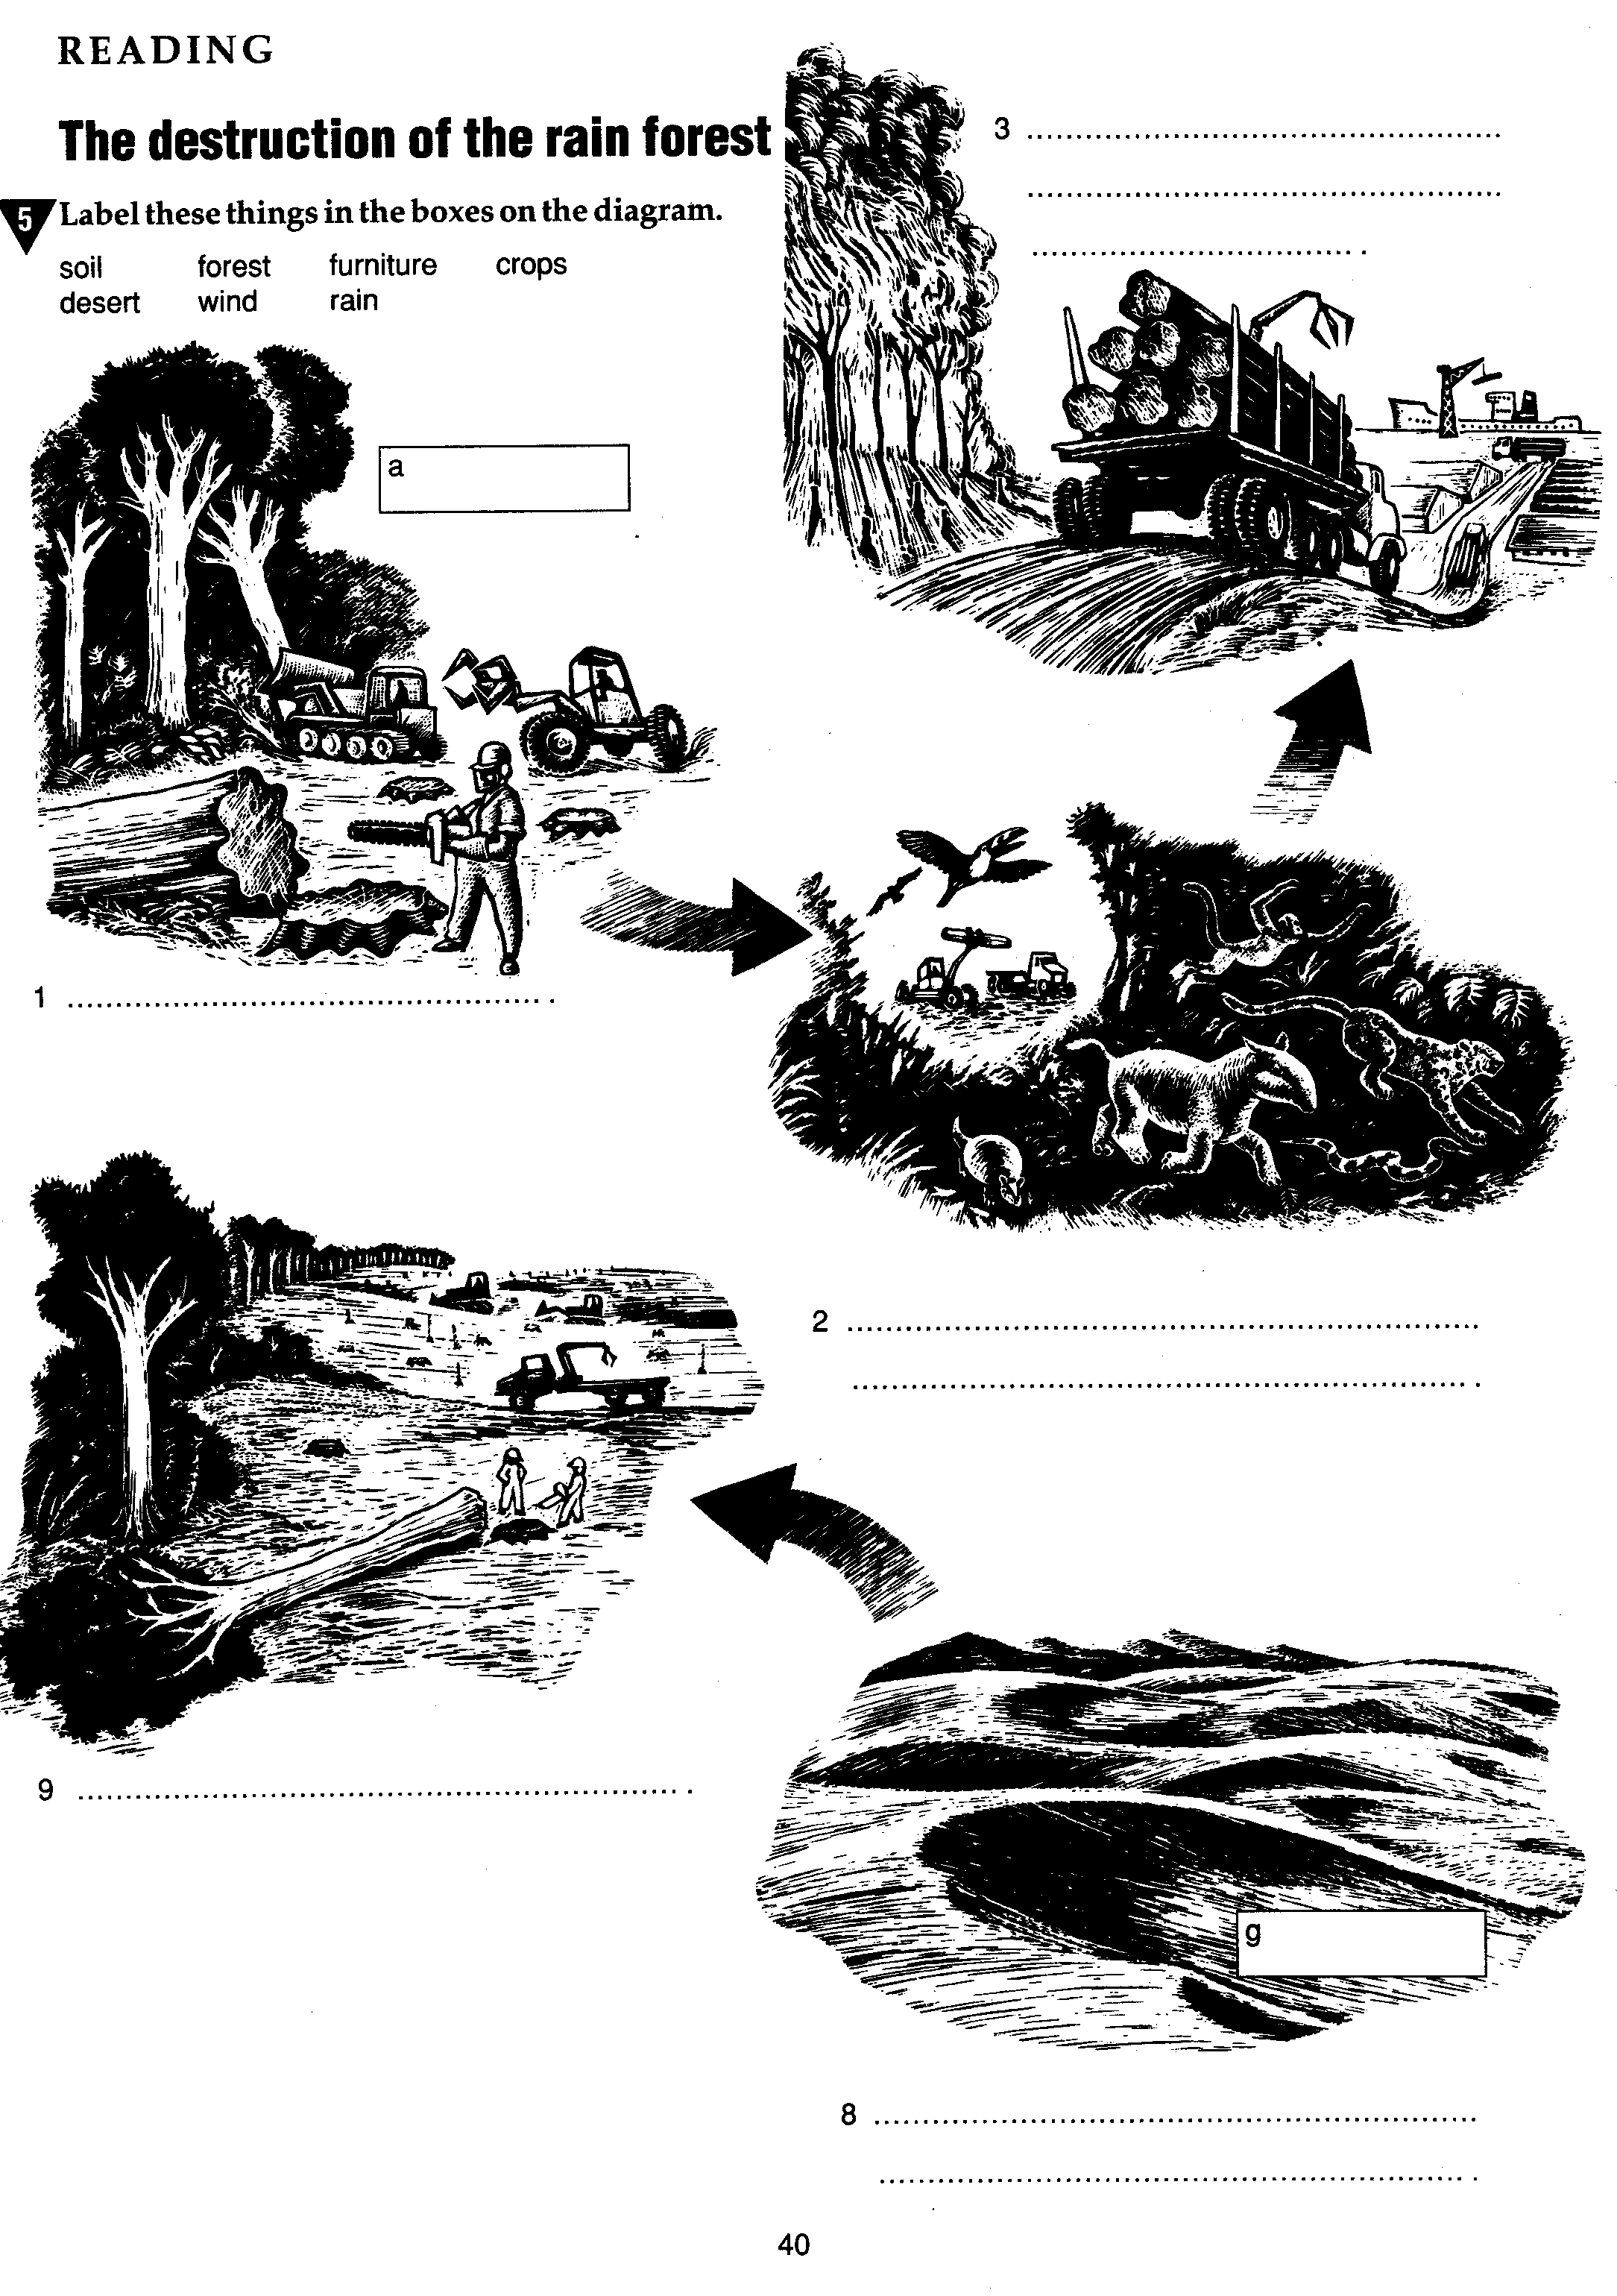
Приложение 2
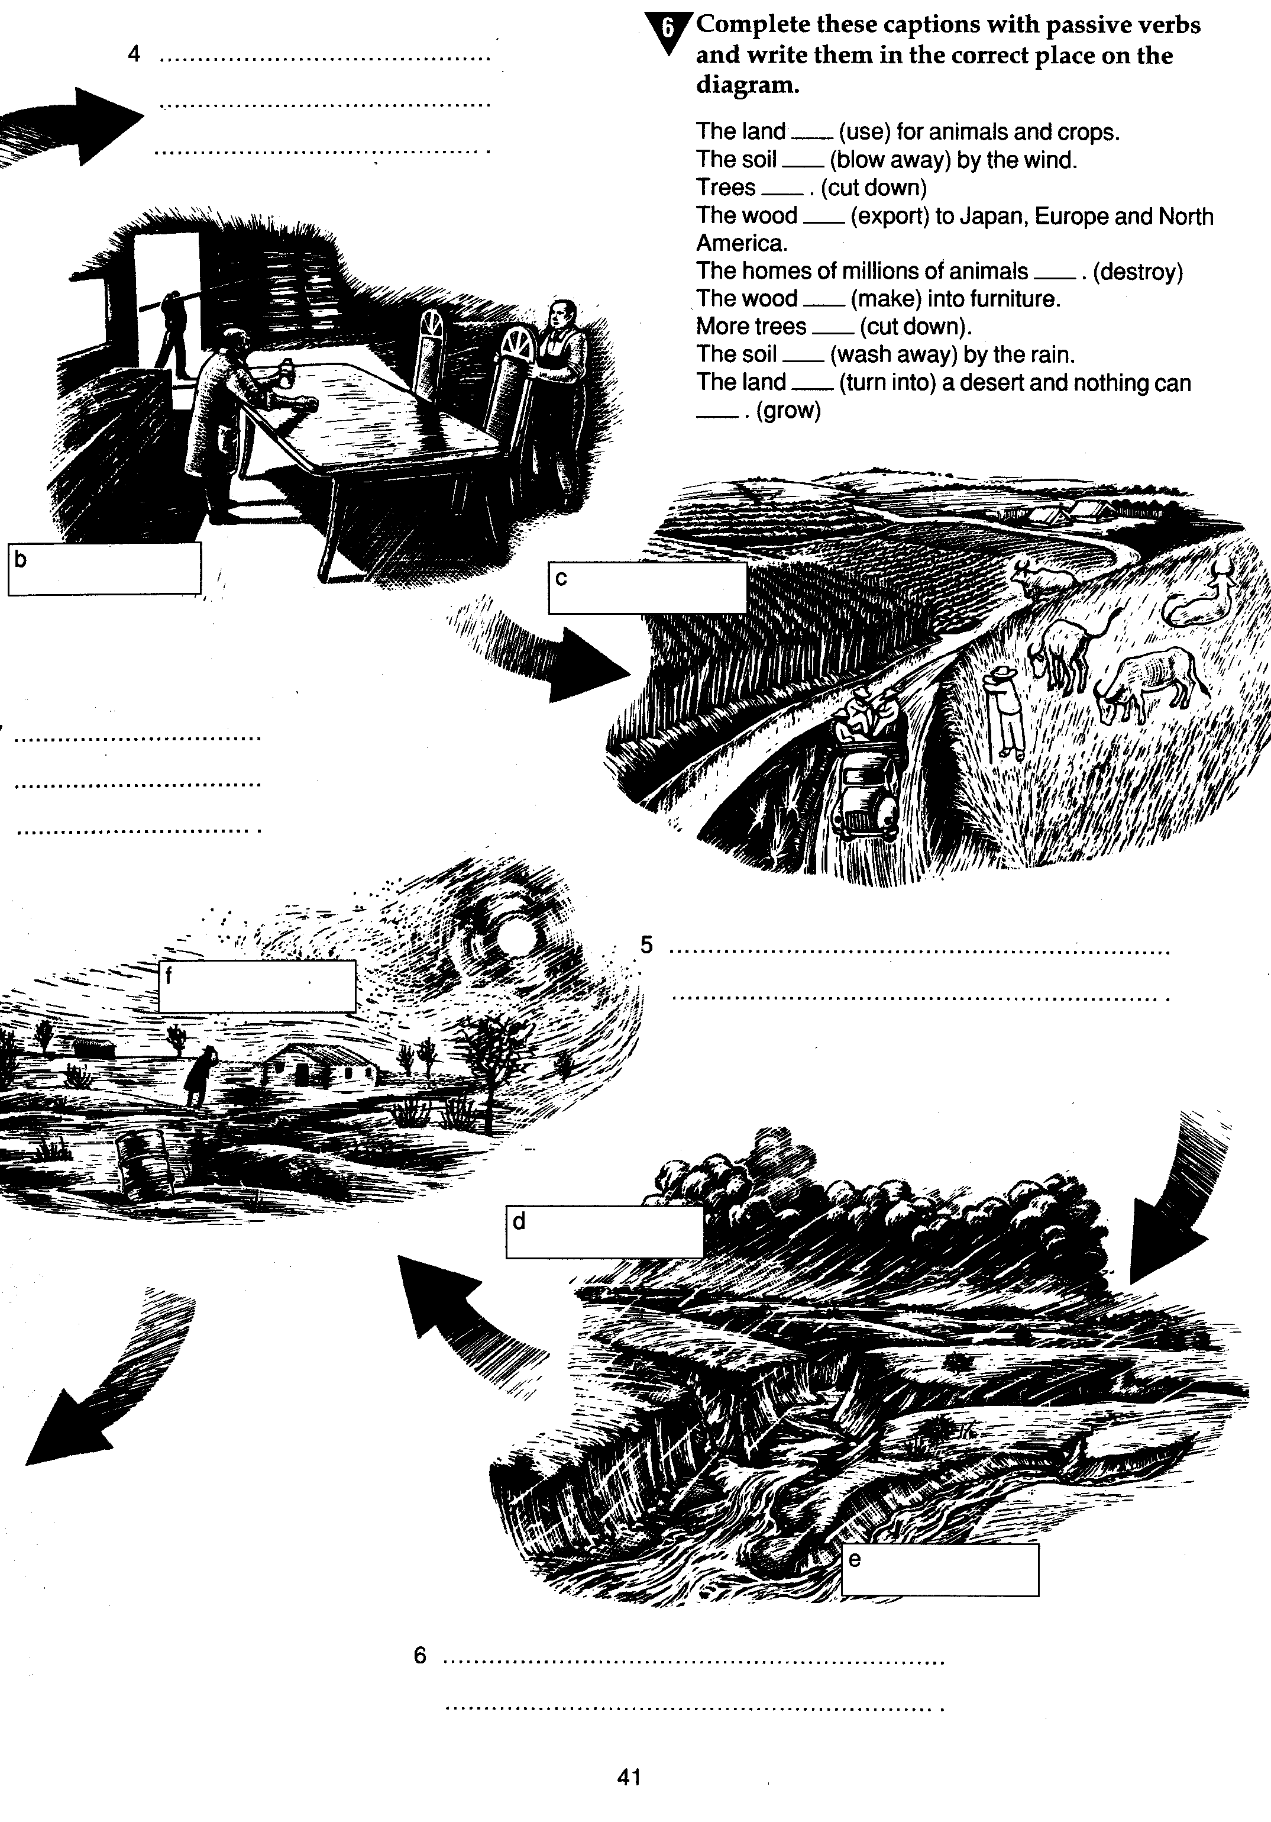
Приложение 3

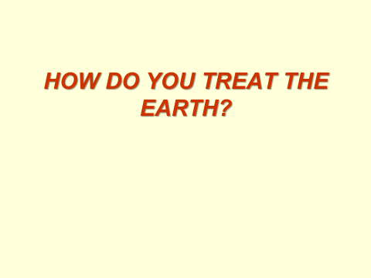
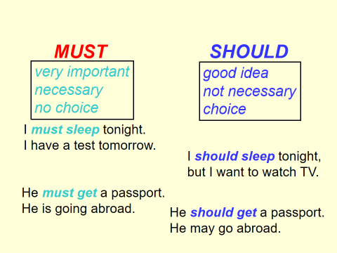
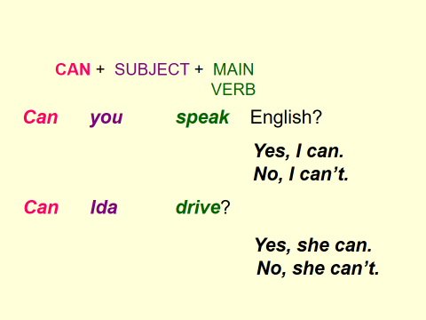
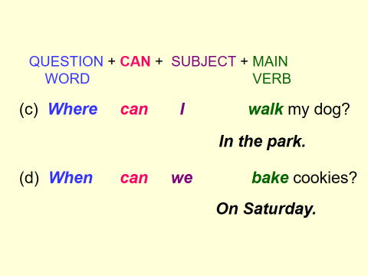
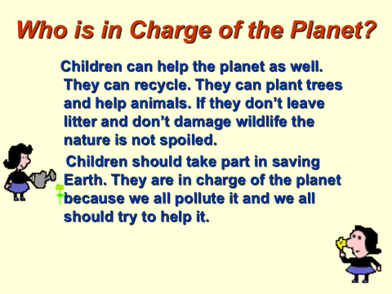
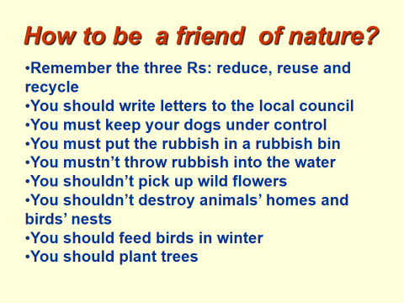
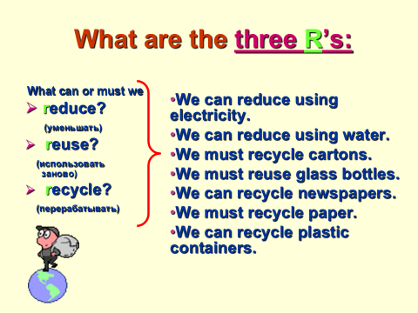

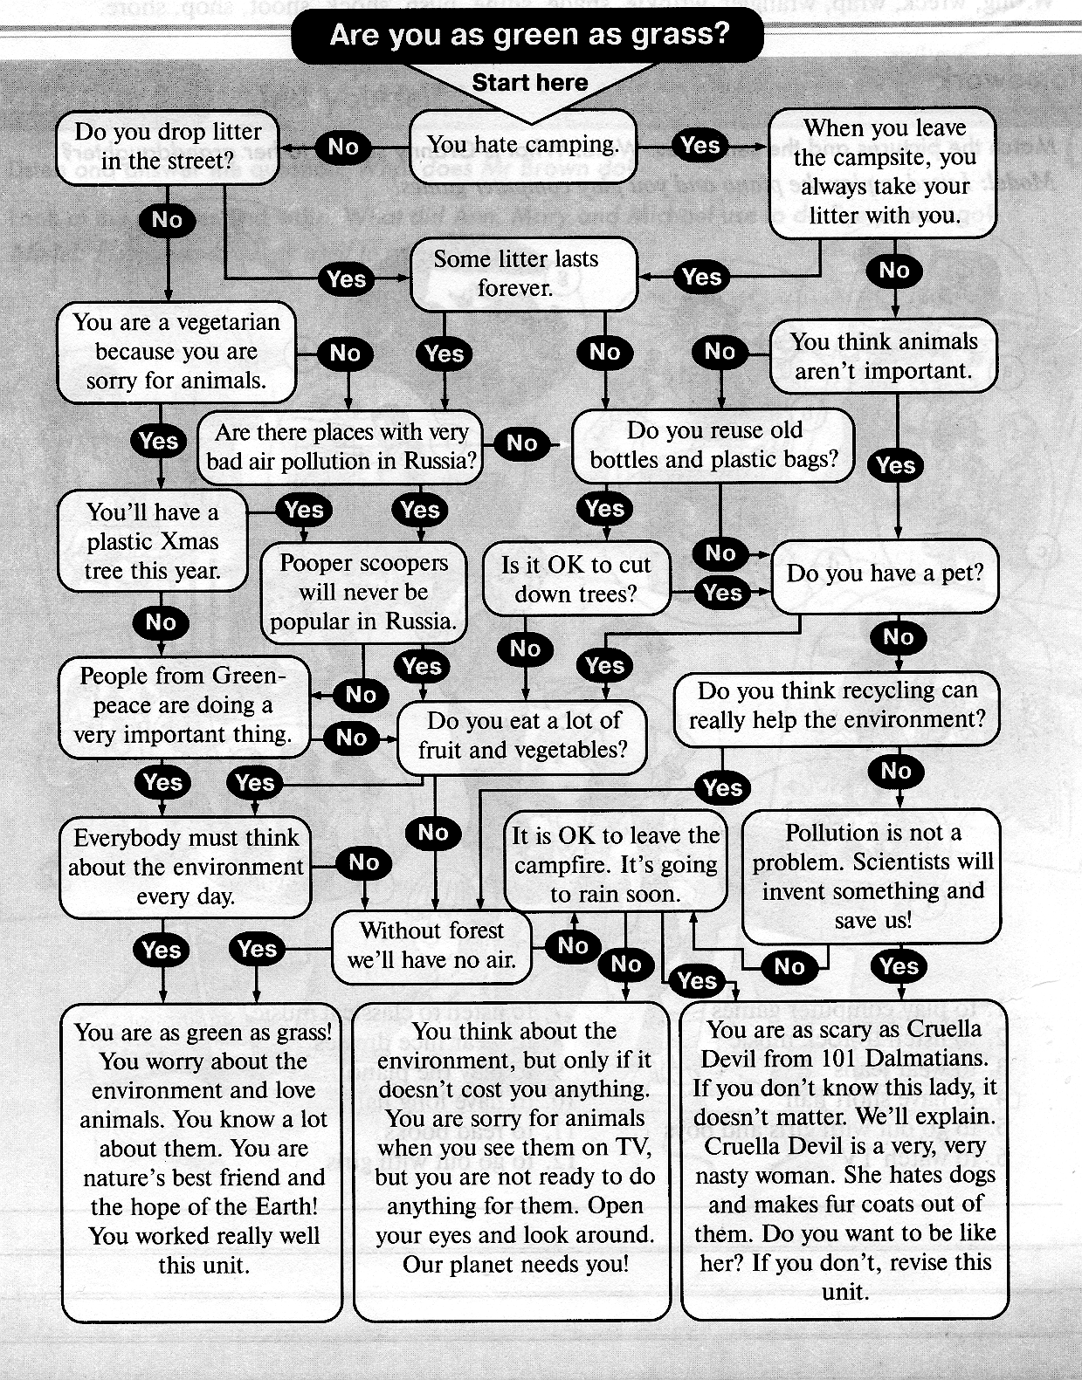
Приложение 4

