1. ИНФОРМАЦИЯ О РАЗРАБОТЧИКЕ ПЛАНА
ФИО разработчика | Кошелева Галина Аркадьевна
Место работы | Великий Устюг МБОУ «СОШ №2 с кадетскими классами»

2. ОБЩАЯ ИНФОРМАЦИЯ ПО УРОКУ
Класс (укажите класс, к которому относится урок): | 7 класс  УМК: О.В. Афанасьева, И.В. Михеева, К.М. Баранова «Rainbow English». Москва «Дрофа» 2017г.
Место урока (по тематическому планированию ПРП) | 6 раздел «Living Healthy».  Урок обобщения и применения ранее усвоенных знаний и умений в новых ситуациях.
Тема урока | Healthy lifestyle
Уровень изучения: | Учебник базового уровня
Тип урока: | Комбинированный урок
Цель урока: повысить интерес школьников к своему здоровью и здоровому питанию.
Основные учебные практические задачи:
1. формирование ключевых компетентностей учащихся на основе комплексного применения знаний, умений и навыков, личного опыта и ценностных ориентаций в решении актуальных проблем.
2. формирование у детей ценностного отношения к собственному здоровью, освоению навыков правильного питания как составной части здорового образа жизни.
3. формирование умения отбора и анализа необходимой информации;
4. формирование умений применять полученные знания по изучаемой теме в проектной деятельности.
Метапредметные УУД:
Личностные: знание основ здорового образа жизни.
Регулятивные: овладение способностью принимать и сохранять цели и задачи учебной деятельности, поиска средств её осуществления; освоение способов решения проблем поискового характера; освоение способов решения задач творческого характера.
Познавательные: находить ответы на вопросы, проводить анализ учебного материала, умение выделять существенную информацию, исходя из требований изначально поставленной задачи.
Предметные: учить употреблять знакомую лексику в различных ситуациях, уметь составлять мини-высказывания и развитие умений представлять результаты своей работы на изучаемом языке.
Коммуникативные: слушать и понимать речь других; формировать умение аргументировано с достаточной полнотой и точностью выражать свои мысли; владеть диалогической формой речи в соответствии с грамматическими и синтаксическими нормами английского языка.
Информационно-интелектуальная компетентность:
- восприятие информации;
- интеллектуальная обработка информации (умение выделять главное в информации, новое в учебном материале);
- результативность интеллектуальной деятельности (способы получения результата, предъявление результата);
- самооценка результата работы.
Используемые технологии: личностно-ориентированная, ИКТ
Формы организации учебной деятельности: фронтальная, работа в парах, самостоятельная работа.
Материалы (ресурсное обеспечение урока):
Учебник, наглядно-иллюстрированный материал, презентация, аудиозапись, запись песни, опоры для построения высказываний учащихся, раздаточный материал: листы с текстами, дополнительной лексикой по теме.
Keywords: vitamins, health, vegetables, fruit, nutrition, energy boost.

БЛОК 1. Вхождение в тему урока и создание условий для осознанного восприятия нового материала
Этап 1.1. Мотивирование на учебную деятельность
Приветствие учителя: Good afternoon, dear children! How are you? How are you, Dasha? etc.
I am fine, thank you!
Беседа с дежурным. What is the date today? What day of the week is it today? What day of the week was yesterday? What is the weather like today? Who is absent today?
Этап 1.2. Актуализация опорных знаний
Заполнить кластер на тему и фонетически отработать слова.
Make an association diagram on the topic «Food»:
Слайд:
Healthy Food

Food (foodstuffs): black bread, white bread, meat, sausage, sausages, ham, fish, vegetables, fruit, berries, mushrooms, salt, sugar, rice, potatoes, milk, cream, cottage cheese, butter, cheese, eggs, tea, coffee.
Answer my questions!
1. What do you prefer to eat? 2. What do you like to drink?
3. What do you prefer to eat the most? 4. What do you like to drink the most?
5. When do you have your evening meal?
6. Can fast food be harmful?
7. Are chips, sweets and cakes junk food?
Этап 1.3. Целеполагание
Введение в тематику урока. Look at the picture and decide what the topic of the lesson is.
Слайд: The aim of the lesson is to talk about «Healthy lifestyle»
Tasks:
speak,
read,
listen,
answer questions,
present the project.
We will talk about healthy lifestyle in English.
We're going to watch a movie.
Give short answers.
Do you think you’re a healthy person?
Do you keep fit?
Do you keep to any special diet?
Do you have regular meals?
Do you have enough sleep?
Do you go to bed on time?
БЛОК 2. Освоение нового материала
Этап 2.1. Осуществление учебных действий по освоению нового материала
1. Read the food pyramids and divide the words into two columns. (p. 112)
healthy unhealthy
milk, vegetables, chips, black bread, sweets, fruit, mushrooms, cola, juice, berries, nuts, cottage cheese
2. Speak about healthy eating habits.
1) Should we eat the same things or different things?
2) What should we eat more?
3) What food should we limit?
4) What rules can you make for yourself?
3. Read the text and complete sentences after it. Выполнение ex. 6 p. 88
Match the questions and answers.
1. Are McDonalds fast food restaurants situated in all countries of the world?
-. The food is fairly tasty.
2. Why do people like to go to McDonalds restaurants?
- Yes, they are.
3. Why do people become obese?
- There is not enough fruit and vegetables on the menu.
4. Is there enough fruit and vegetables on the menu?
- Eating such food regularly is risky because the food is low in vitamins.
5. Why is junk food unhealthy?
- They are fond of junk food – hamburgers, cheeseburgers, chips, cakes and so on.
4. The right diet. Раздаточный материал.
Remember! Useful (полезный), regular (регулярно), chat (болтать, разговаривать), harm (вредить), necessarily (непременно), vitamin-rich (богатый витаминами), nutritious (питательный), the protein (белок), habits (привычки), the diet (пища, еда)
People usually eat 3 or 4 times a day. But not all foods are useful. In addition, some people eat irregularly and the break between meals is very long. Others read or chat while eating. This is also bad for health. The food should not be too hot or too cold. The right food must be rich in vitamins. It is very healthy for children and adults to eat porridge in the morning. It is very useful and nutritious. Oatmeal is the most popular choice, of course, because it is rich in vitamins. You need to eat fruit and vegetables regularly to be strong and healthy and to live a long time without illness. Dairy products are also healthy food, especially for children. Fish is rich in protein and very nutritious. There are many vitamins in black bread. You shouldn't eat much in the evening; otherwise you will have trouble sleeping.
1) Healthy or unhealthy? Let's determine what is healthy and what is unhealthy. Put the sentences together. Слайд
It is healthy to eat twice a day.
to eat porridge in the morning.
to eat too hot and too cold.
to eat regularly.
to read or chat while eating.
It is unhealthy to eat food rich in vitamins.
to eat 3 or 4 times a day.
to eat black bread.
to eat a lot of vegetables and fruit.
to be a sweet tooth (сладкоежка).
It’s not useful to eat junk food almost every day.
to eat fast food regularly.
2) Make up sentences! Do this task orally.
(На листочках дети получают следующие слова):
1. a, would, you, like, cheese, sandwich?
2. me, Excuse much how the cucumber is salad?
3. I, to eat, like, in the morning, would, porridge.
4. There, food, everyone, for, is, enough.
5. Have, enough, got, apples, we, everybody, for?
6. care, We, of take, our health,
5. Vitamins. What is that?
The word «vitamins» comes from Latin: «vita» - «жизнь».
Read the text and find the translation of the following sentences in the text:
1. Это биологически активные вещества, без которых невозможны нормальные жизненные процессы. 2. Название «витамины» происходит от латинского «vita», что значит «жизнь». 3. Отсутствие или недостаток витаминов вызывают различные заболевания. 4. Особенно много витаминов содержится в свежих овощах и фруктах. 5. Витамины теряются при транспортировке и хранении овощей и фруктов, а также отрицательно действуют на них свет и высокая температура.
1. The word «vitamins» comes from Latin: «vita» - «жизнь». 2. These are biologically active substances, without which normal life processes are impossible. 3. The absence or lack of vitamins cause various diseases. 4. Vitamins are indispensable elixirs of life. 5. Fresh vegetables and fruits contain especially many vitamins. 6. Vitamins are lost during transportation and storage of vegetables and fruits, and they are also negatively affected by light and high temperatures.
Этап 2.2. Проверка первичного усвоения
Слайд
1) What does the word "vita " mean?
2) Name 5 verbs! Underline the words in the text that answer the following questions:
1. What role do vitamins play?
2. Why do diseases occur?
3. When and how do vegetables and fruit lose their vitamins?
Formulate the basic rules of healthy eating!
Convince me that you take care of your health and eat food rich in vitamins.
1. I keep to a healthy diet.
2. I eat a lot of vegetables and fruits because they contain vitamins.
3. I like to eat raw vegetables. People eat raw vegetables because they contain all the vitamins and minerals that are important for the body, and they are destroyed when they are heated. These include green peppers, onions, spinach, and parsley.
4. I eat regularly. I eat black bread because it stabilizes my digestive system.
5. I eat berries and mushrooms. Edible mushrooms help to strengthen the immune system. Berries contain minerals and all vitamins (except B12).
6. I eat porridge in the morning because it gives my body energy.
7. I don't eat much in the evening. People should not eat a lot before bedtime for the following reasons:
the risk of weight gain,
digestive problems,
sleep disturbances.
8. I eat dairy products because they stimulate energy.
9. I eat soup for lunch because it stimulates digestion.
10. I don't eat too hot or too cold food. Very hot and cold food can cause stomach problems.
11. I prefer to eat food rich in vitamins.
БЛОК 3. Применение изученного материала
Этап 3.1. Применение знаний, в том числе в новых ситуациях
Учащиеся читают нелинейный текст и заполняют пробелы по карточкам, используют раздаточный материал. Работа в парах.
Vitamin-rich food, vitamins in food.
We absorb most vitamins through food. Important sources of vitamins are fresh fruit and vegetables, berries, whole meal bread, cottage cheese, meat, fish, eggs, milk and butter.
Vitamin | Function | Food
A | for bones, teeth, skin, hair, eyes | green, yellow and red vegetables, apricots, cantaloupes, liver, butter, egg yolk, cream
B | for good nerves, heart, eyesight, growth | nuts, dairy products, whole grains, green beans, potatoes, meat, fish, cabbage, apples, bananas
C | for the immune system, eyesight, gums, sleep, concentration, positive mood and stress management | Raw vegetables and fruits, berries, herbs
D | for bones, teeth, good nerves, optimism; is also formed in the skin under exposure to the sun. | Fish, eggs, mushrooms, liver, fish oil, dairy products
E | for healthy blood, healthy eyes | Butter, egg yolk, meat, liver, sunflower oil, oatmeal, buckwheat, fish oil
Речевая опора:
- … contain vitamin A.
They are important for …
- … contain vitamin B.
They are important for …
- … contain vitamin C.
They are important for …
Составьте диалог, расставив реплики в правильной последовательности». После того как учащиеся составят диалог, читают по ролям
- Olya, you look great. Do you think you’re a healthy person?
- I feel healthy.
- What do you usually eat for breakfast?
- I usually eat porridge, fried eggs or cottage cheese with cream, and I drink tea. What about you?
- I don't like fried eggs and cottage cheese. I eat oatmeal or white bread with butter and cheese, and I drink tea or coffee with milk. It's delicious. How do you take care of your health?
- I follow a special diet.
- What about physical exercise? Do you run or play tennis?
- I keep fit. I play tennis with my friends.
Describe the pictures according to the sample!



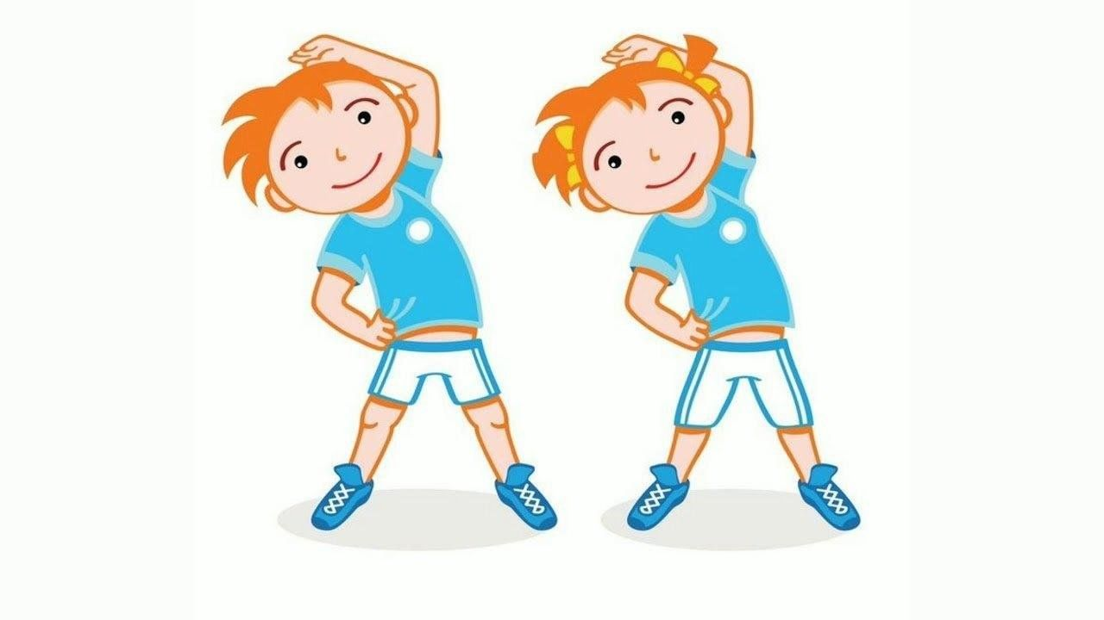
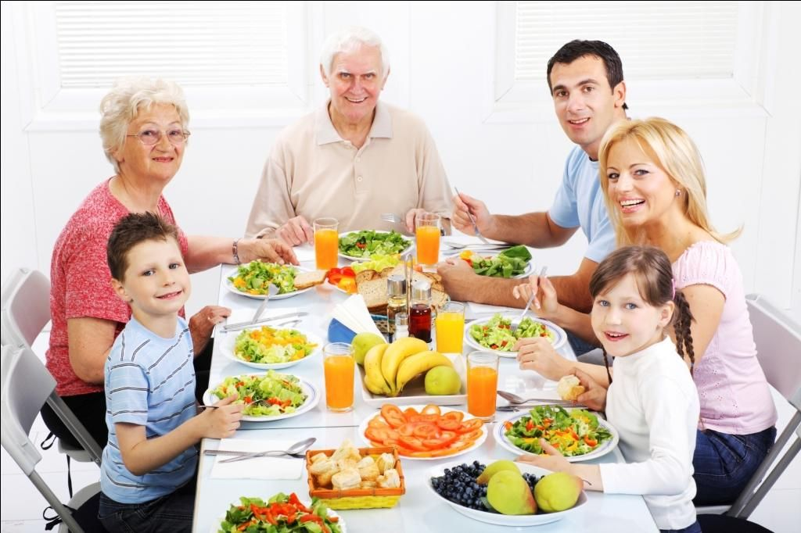

Example: Swimming does them a lot of good.
Этап 3.2. Выполнение межпредметных заданий и заданий из реальной жизни
1. Read the statements first. Tick: true (t) or false (f).
true/false
1) Vitamins and minerals help you to be healthy and stay healthy. t. f.
2) Sweets and chips are healthy. t. f.
3) Butter and meat make you strong. t. f.
4) Black bread gives you energy. t. f.
5) Vegetables and fruit are rich in vitamins. t. f.
6) We don't live to eat, we eat to live. t. f.
7) Omelette is a meat dish. t. f.
2. Put the proverbs together.
1. After dinner sit a while, a staff of live.
2. A sound mind drink with measure.
3. Diseases are the doctor away.
4. An apple a day keeps the interests of pleasure.
5. Eat at pleasure in a sound body.
6. Bread is after supper walk a mile.
Этап 3.3. Систематизация знаний и умений
Группа учащихся представляет заранее подготовленный проект на тему «Healthy lifestyle».
Project «Healthy Food»
Relevance:
Today, there are a lot of food products in our stores. Some of them are in very attractive plastic packaging. Children love to buy them. Many of these products can be harmful to health because they often contain a lot of artificial additives.
Everyone needs to know which products are good for health. Our food must be natural and contain vitamins and minerals.
Problem: Pupils do not pay enough attention to their health.
Hypothesis: Food rich in vitamins is necessary for the health and functioning of the body.
Goal: Formation of a proper diet and a healthy lifestyle.
Tasks: Find and analyze information on the topic.
Research object: food.
Research subject: healthy food.
Pupil 1: I like to eat spinach and onions willingly. They contain vitamin A and are important for bones, teeth and eyes.
Pupil 2: I like vegetable salad, especially cabbage or carrots. Green and yellow vegetables contain vitamin A. Vitamin A is important for bones, teeth, skin, hair, eyes.
Pupil 3: For breakfast I eat white bread with cheese. Cheese contains vitamin B. Vitamin B is important for good nerves, visual acuity and growth.
Pupil 4: I like eating apples most of all. The apples are very tasty. They contain vitamin B and are important for the heart, eyesight and growth. Apples are also rich in vitamin C, which our bodies need. An apple a day keeps the doctor away. Apples are a symbol of a healthy diet. A proper and healthy diet reduces visits to the doctor.
Pupil 5: I eat a lot of vegetables and berries. They contain vitamin C. Vitamin C is important for the immune system, visual acuity, and positive mood. Eating healthy food helps us keep fit.
Pupil 6: I eat vegetables and berries. They are important for good concentration and positive mood. Healthy eating helps us avoid obesity.
Pupil 7: I love green vegetables and berries. They are important for good concentration and a positive mood.
Pupil 8: I drink milk willingly. It is useful to eat dairy products. They contain vitamin D. Vitamin D is important for bones, teeth, good nerves.
Pupil 9: I like fish and liver. Fish and liver are nutritious. They contain vitamin E. Vitamin E is important for healthy blood and healthy eyes.
Conclusion:
Working with literature on the topic, we learned a lot of new and useful things. We found out how important it is for a person's diet to include healthy, necessary products containing vitamins and minerals.
Eat only healthy foods, strengthen your immune system!
БЛОК 4. Проверка приобретенных знаний, умений и навыков
Учащиеся смотрят фильм на английском языке. Демонстрация фрагмента фильма 3 минуты.
После просмотра фильма учащиеся заполняют текст с пропусками и сверяют свои ответы со слайдом.
Этап 4.1. Диагностика/самодиагностика
The family came to the … for … . They followed the … and sat down at a … for four people. The family asked for a menu. They chose drinks: water, lemonade, milkshake (молочный коктейль) and … juice. For the first course, … ordered vegetable soup, while Amy and Paul chose … soup. For the main course, … and Paul ordered grilled chicken and some … , while the mother decided to have … fish. She loved fish. It was … . Amy ordered lasagna because it was her … dish. They ordered ice cream, … cake and cheesecake for dessert. They paid the … and enjoyed their … .
«5» - score 13-15 words
«4» - score 10-12 words
«3» - score 7-9 words
БЛОК 5. Подведение итогов, домашнее задание
Этап 5.1. Рефлексия
В виде вопросов
Деятельность учителя:
What new and interesting things did you learn in the lesson? Are you satisfied with your work in the lesson? What did you learn today? Was it easy or difficult to complete the tasks? Can you tell us something about healthy food?
I am satisfied with my work in the lesson... . I worked... . I understood that... . Now I can... Today I learned... It was difficult... It was easy... . I want to... .
Were you active in class?
You all did a great job. Thank you!
Оценивание. Your grades are . .. .
Этап 5.2. Домашнее задание. Write an essay on the topic "Healthy Eating"
The lesson is over. Goodbye!

