**Всероссийский конкурс для учителей**

**и педагогов дополнительного образования**  
**"Лучшая методическая разработка с использованием современных образовательных технологий и методик"**

**Интеллектуальная викторина**

**по страноведению на английском языке**

**«What do you know about Britain?», 10 класс**

**Автор**: Жигунова Оксана Игоревна,

учитель иностранного языка,

МБОУ «Средняя общеобразовательная школа №19

с углубленным изучением отдельных предметов»,

г.Черногорск Республики Хакасия

**Пояснительная записка по конкурсу страноведения на английском языке для учащихся 10 класса**

Интеллектуальная викторина в формате квест- игры «What do you know about Britain?» представляет собой задания по станциям, в которых учащимся требуется заполнить пропуски нужной информацией. Перед началом урока учащиеся делятся на группы для прохождения заданий. Им выдаются бланки

«Answer form team ___ », в которые они записывают

**Целью викторины является** воспитание у учащихся толерантного отношения к истории и культуре Великобритании, расширение кругозора учащихся о стране, по средствам метапредметных знаний, полученных на учебных предметах «География», «История», «Обществознание», «Мировая художественная культура», а также повышение мотивации учащихся к изучению английского языка.

**Задачи викторины:** активизировать и закрепить ранее изученные страноведческие факты о Великобритании.

Викторина может быть использована на уроках в распечатанном виде, либо с использованием мультимедийного оборудования.

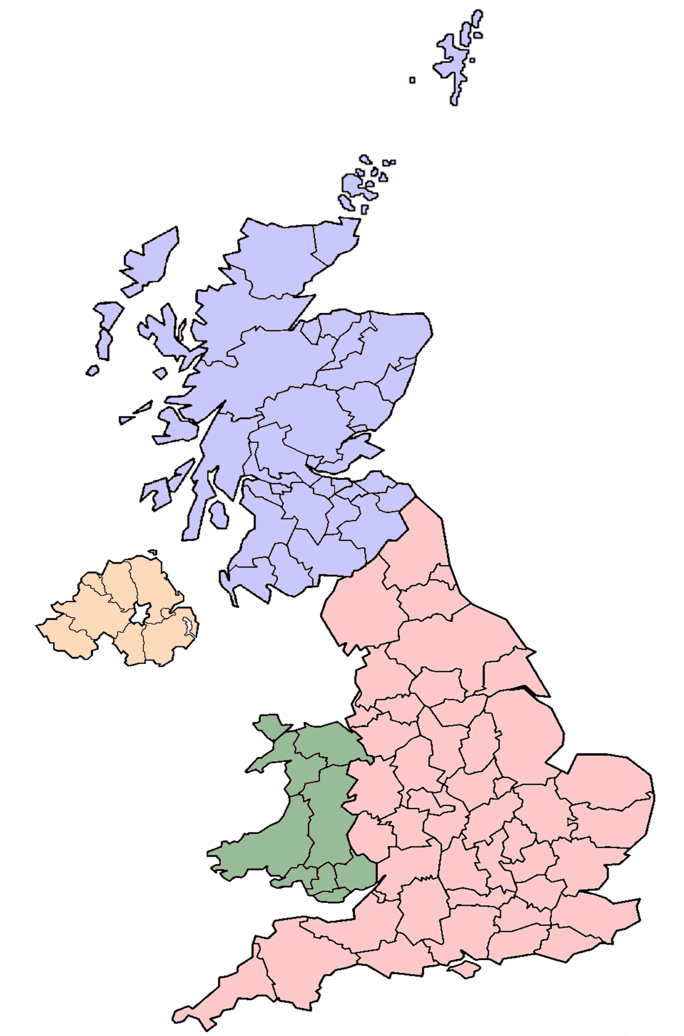

*Question 1*

The United Kingdom of Great Britain and Northern Ireland is situated on ……

*Question 2*

The British Isles consist of ......

*Question 3*

The United Kingdom is made up of ...... countries

*Question 4*

…… is the capital of England

*Question 5*

...... is the capital

of Wales

*Question 6*

…… is the capital

of Scotland

*Question 7*

…… is the capital

of Northern Ireland

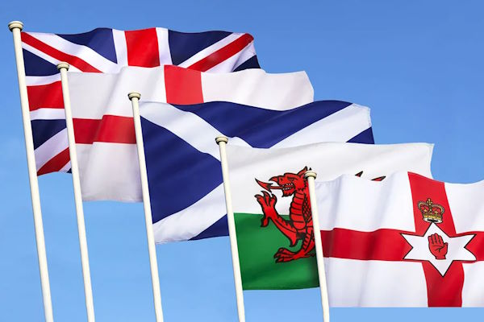

*Question 2*

…... is the national emblem of England (flower)

*Question 1*

…… is the symbol of the typical Englishman

*Question 3*

...... is the national flower of Scotland

*Question 4*

…… is the national symbol of Northern Ireland (flower)

*Question 5*

...... is the national emblem

of Wales (flower)

*Question 6*

...... is the patriotic colour

of England

*Question 7*

…… is the patriotic colour of Scotland

*Question 8*

…… is the patriotic colour

of Wales

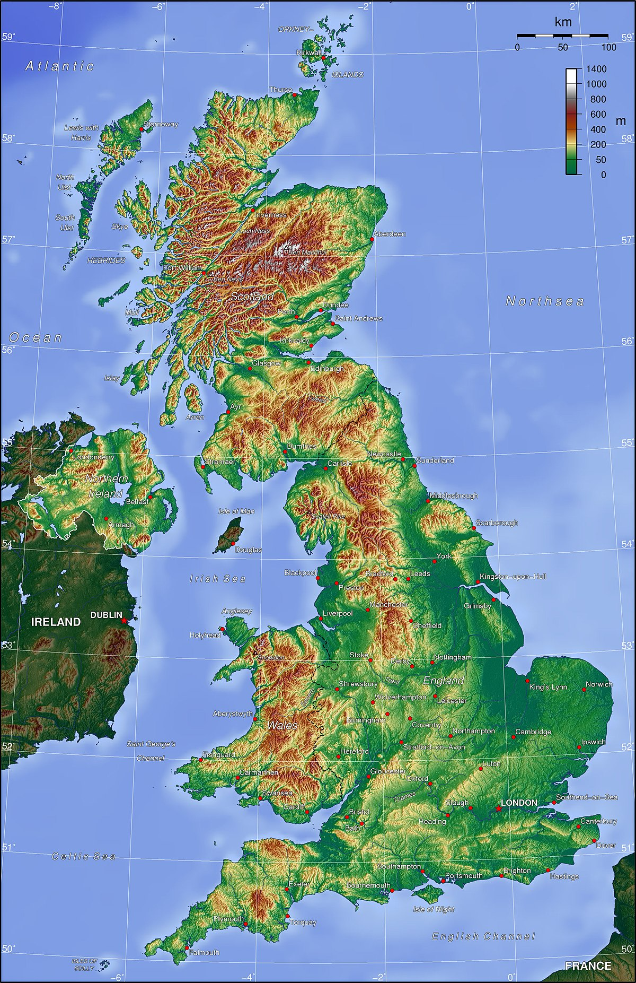

*Question 1*

The western coast of Great Britain is washed by ……

*Question 2*

….is the longest river in Great Britain

*Question 3*

….is the deepest river in Great Britain

*Question 4*

The north of Scotland is mountainous and is called ….

*Question 5*

….is the highest mountain in Scotland

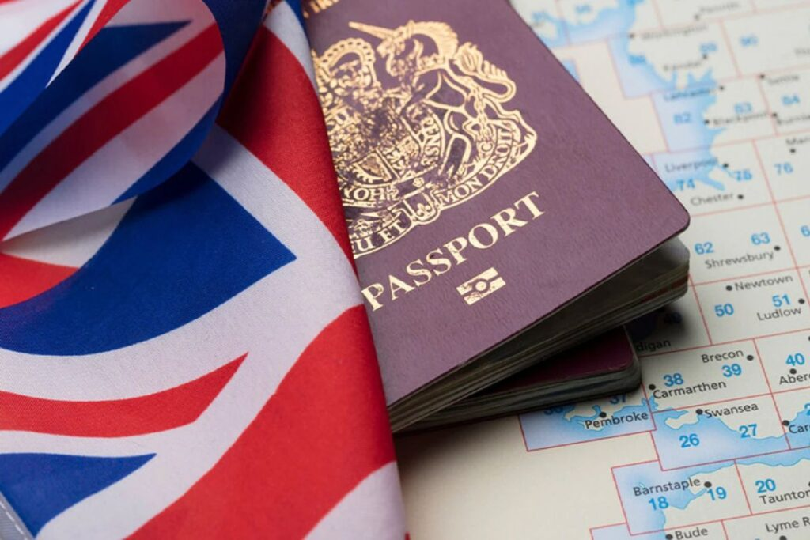

*Question 1*

The United Kingdom of Great Britain and Northern Ireland is a constitutional ……

*Question 6*

The Commons control …… branch of power

*Question 2*

Great Britain is governed by ……

*Question 8*

…… can revise and delay bills.

*Question 10*

The Prime Minister chooses

Cabinet and …. ministers.

*Question 9*

The British Parliament appoints …

*Question 7*

The British Parliament makes ……

*Question 5*

The members of the House of Commons are elected

by ……

*Question 3*

The head of State is …...

*Question 4*

The British Parliament consists of two chambers: …...

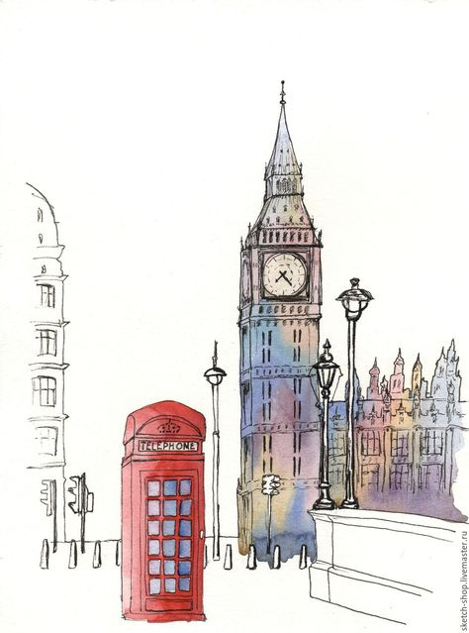

*Question 3*

…… (in London) is the district where mostly working people live.

*Question 1*

The ancient buildings of London are: ……

*Question 5*

The famous Gardens of London are ……

*Question 10*

Famous prisoners of the Tower of London are ……

*Question 9*

The Tower of London used to be ……

*Question 8*

People usually watch …… In the forecourt of the Buckingham Palace.

*Question 7*

…… is the Queen`s official London residence.

*Question 6*

During the reign of Edward the Confessor the Palace of …… was the royal residence.

*Question 2*

…… (in London) is a rich man`s world of shops, offices and theatres

*Question 4*

The famous park of London is ……



*Question 7*

_____________________

*Question 2*

_______________________

*Question 1*

_____________________

*Question 6*

______________________

*Question 5*

_____________________

*Question 4*

__________________

*Question 3*

_____________________



*Question 1*

__________________

*Question 2*

________________________

*Question 3*

________________________

*Question 4*

________________________

*Question 5*

________________________

*Question 8*

__________________

*Question 7*

________________________

*Question 6*

________________________



*Question 1*

______________________

*Question 2*

______________________

*Question 3*

___________________

*Question 5*

______________________

*Question 4*

______________________



*Question 6*

______________________

*Question 2*

______________________

*Question 1*

______________________

*Question 9*

______________________

*Question 8*

______________________

*Question 7*

______________________

*Question 5*

______________________

*Question 4*

______________________

*Question 3*

______________________

*Question 10*

______________________



*Question 1*

______________________

*Question 3*

______________________

*Question 2*

______________________

*Question 4*

______________________

*Question 6*

_____________________

*Question 5*

______________________

*Question 7*

______________________

*Question 8*

______________________

*Question 9*

______________________

*Question 10*

______________________

Answers to the stations' questions

Station № 1

1. The British Isles
2. Two large islands (Great Britain and Ireland)
3. Four countries (England, Wales, Scotland and Northern Ireland)
4. London
5. Cardiff
6. Edinburgh
7. Belfast

Station № 2

1. John Bull
2. The Red rose
3. The Thistle
4. The Daffodil
5. The Shamrock
6. White
7. Blue
8. Red

Station № 3

1. The Atlantic Ocean and the Irish Sea
2. The Severn
3. The Thames
4. Highlands
5. Ben Nevis

Station № 4

1. Monarchy
2. The Parliament
3. The King
4. The House of Lords and the House of Commons
5. The people
6. The executive
7. Laws
8. The Lords
9. Prime Minister
10. non –cabinet

Station № 5

1. The Tower of London, Westminster Abbey, St. Paul`s Cathedral.
2. The West End
3. The East End
4. Hyde Park
5. Kensington Gardens
6. Westminster
7. Buckingham Palace
8. The Changing of the Guards
9. A fortress, a palace, a prison, a mint
10. Sir Thomas More and Guy Fawkes