Урок английского языка «British Parliament».
8 класс
Цель: Развитие навыков устного высказывания и навыков коммуникативного общения в рамках предложенной темы.
- Образовательная:
Активизировать и закрепить лексику по теме «British Parliament» по видам речи.
- Развивающая:
Развивать навыки говорения в беседе о политическом устройстве Великобритании.
- Воспитательная:
Воспитывать толерантность, уважения к культуре других народов, чувство гордости за свою страну.
Задачи:
- активизировать и закрепить лексику по теме;
- тренировать навыки говорения;
- развивать умения и навыки работы в группе.
Тенология - обучения в сотрудничестве
Формы организации познавательной деятельности: групповая
Ресурсы: проектор, слайды, раздаточный материал, видеоролики
Ожидаемые результаты: учащиеся умеют говорить о политической системе Великобритании, знают основные политические цифры, умеют анализировать и сравнивать данную информацию.
Ход урока
Время (40мин.) | Этапы проведения урока | Деятельность учителя и учащихся
2 минуты | Организационный момент | T: Hello everyone! Nice to see you! How are you today? Ok, fine. We have guests so don’t be shy, be active and smart and try to show all your knowledge. And I’d like you to work in groups and choose the person who fills in the assessment card.
2 минуты  4 минуты | Развитие речевых навыков  Развитие навыков аудирования | T:Ok, let’s start. I’d like you to have a look at the board. Look at this picture and describe what you see.  The structure “See-think-share”  P1P2P3… I see …  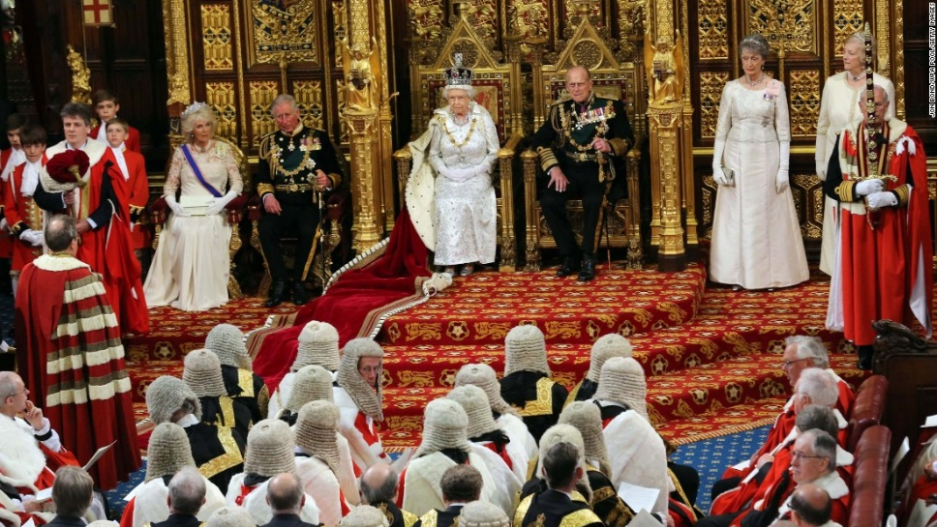  All these things are related to our topic “British Parliament”  Let’s start from the video news. The speech is very fast but try to find out what these numbers mean second, 10, 59  Questions:  - What period are the Members of the House of Commons elected for?(5 years)  - When did Elizabeth II come to the throne? (1952 after the death of her father George VI)  3. How many times can a bill be read in the Parliament? (3)  4. How long do the sessions last in the Parliament? (160 days a year)  5. How many children does the Queen have? (4: Charles, Anne, Andrew, Edward)  Просмотр видео новостей о Терезе Мэй
5 минут | Тренировка навыков устной речи (повторение лексики) | T: First let’s revise the words and word expressions. Look at the blackboard the task is here. Find the correct translation to each of these words. (два ученика работают у доски)  the head of state – глава государства  government государство  the House of Lords – палата лордов  the House of Commons – палата общин  hereditary peers – наследственные пэры  the Labour Party – партия лейбористов  the Conservative Party – партия консерваторов  the Speaker – спикер  the Lord Chancellor – лорд – канцлер  to inherit – наследовать  to consist of – состоять из  to elect – выбирать  to vote – голосовать  to approve – одобрять  лексика повышенного уровня  a constitutional monarchy – конституционная монархия  the legislative power – законодательная власть  to be exercised by – осуществляться ( чем-либо)  to be elected by the people – избираться народом  the real governing body – реальный правящий орган  the executive power – исполнительная власть  the Prime Minister – премьер министр  to be appointed by – назначаться (кем-либо)  the judiciary branch of the government – судебная ветвь власти  to be independent of – не зависеть от чего либо  работа с остальными  T: Ok, boys and girls I have some pictures tell me what can you see. For example, this the queen Elizabeth II who is the head of state now. (the Chamber of the House of Lords, Speaker, the mace, the throne, the Chamber of the House of Commons, the Palace of Westminster).  You can use the prompts that on the screen.  On the screen:  ...where the queen sits  ...who presides over the House of Commons  ...where the lords and ladies sit  ...which lies on the table when the house is debating  ...where the British Parliament sit  …where MPs sit.  Good job! I’m really proud of you!  В приложении наглядность
10 минут | Активизация навыков монологической речи с опорой на текст | T:And now I’ll give you some time to discuss the following questions with your group: what do you know about legislative power, executive and judiciary. Again, you have text to find out necessary information.  Ps: tell about three branches of power  Excellent! You are doing really great work!  текст “UK political system”.
5 минут | Физкультминутка | T:I think it’s high time to relax watching the video about Royal family
7 минут | Развитие навыков монологической речи | T: Dear friends let’s sum up and make a conclusion about UK Political system. Ok I’m sure you can. who’s ready.  Hope that now you know a lot about politics.
3 минуты | Рефлекия | Great! Well done! Give me your assessment cards. Your marks …  Good bye everyone!

Assessment card
Listen and draw the face  or 
Name | … answers the questions | … knows the words | …tells about UK political system | … very active | Mark

UK POLITICAL SYSTEM

The United Kingdom of Great Britain and Northern Ireland is a constitutional monarchy. This means that Great Britain is governed by the Parliament and the Queen is Head of State.
The legislative power in the country is exercised by the Houses of Parliament. The British Parliament consists of two chambers: the House of Lords and the House of Commons. The House of Lords is composed of hereditary and life peers and peeresses. The members of the House of Commons are elected by the people. They are elected from the constituencies in England, Scotland, Wales and Northern Ireland. The House of Commons is the real governing body of the United Kingdom.
The executive power is exercised by the Prime Minister and his Cabinet. The government is usually formed by the political party which is supported by the majority in the House of Commons. The Prime Minister is the majority party leader and is appointed by the Queen. The Prime Minister chooses a team of ministers; twenty of the ministers are in the Cabinet.
The second largest party becomes the official opposition with its own leader and the Shadow Cabinet. The two leading parties in Great Britain are the Conservative Party (the Tories) and the Labour Party.
The judiciary branch of the government determines common law and is independent of both the legislative and the executive branches.
There is no written constitution in Great Britain, only precedents and traditions.

